Development of 6DOF Robotic Arm in

Agricultural Phenotyping

|  |  |
| --- | --- |
| Lai Hong You (151768) | Justin Chia Vern Shuen (151962) |
| *School of Electrical and Electronic Engineering* | *School of Electrical and Electronic Engineering* |
| *Universiti Sains Malaysia* | *Universiti Sains Malaysia* |
| *14300, Nibong Tebal, Pulau Pinang, Malaysia* | *14300, Nibong Tebal, Pulau Pinang, Malaysia* |
| hongyoulai@student.usm.my | justinchiavernshuen@student.usm.my |

|  |  |
| --- | --- |
| Thow Zhi An (154041) | Tiong Ji Kai (151334) |
| *School of Electrical and Electronic Engineering* | *School of Electrical and Electronic Engineering* |
| *Universiti Sains Malaysia* | *Universiti Sains Malaysia* |
| *14300, Nibong Tebal, Pulau Pinang, Malaysia* | *14300, Nibong Tebal, Pulau Pinang, Malaysia* |
| zhian@student.usm.my | jikai@ student.usm.my |
| Submission date: 5 July 2023 | |
|  |  |

***Abstract* - The use of the 6 degrees of freedom (DOF) robotic arm in plant phenotyping could revolutionized the agriculture sector in Malaysia. It allows for advanced and accurate plant traits detection along with precise agricultural management. Besides, the 6DOF robotic arm enhances the flexibility and accuracy for sensors placement and plant phenotypes collection. It could execute more precise tasks such as plant handling, sensor deployment, imaging, data collection, and sample collection with better accuracy and resolution. With robotic arm equipped, it facilitates high-throughput phenotyping, accurate irrigation, treatment, as well as targeted weeding and pruning. Researchers can streamline data collection, improve scalability, and gain deeper insights into plant traits and their interactions with the environment on a larger scale with smaller labor effort. This article is mostly focusing on the software and hardware development of the 6DOF robotic arm. The overall process of development is described and the direction of the future improvement of the robotic arm are discussed as well. The potential, benefits and challenges associated with implementation of 6DOF Robotic arms to transform agricultural phenotyping are discussed.**

***Index Terms – 6DOF robotic arms, agricultural phenotyping, LabVIEW programming, agricultural management.***

1. Introduction

Agricultural phenotyping technology holds immense importance in advancing the field of agriculture. Phenotyping, the measurement, and analysis of plant traits enables researchers and farmers to gain valuable insights into crop performance, disease resistance, and resource utilization. By employing advanced sensing technologies and data analysis techniques, phenotyping enhances the understanding of plant growth and development, facilitating targeted interventions for improving crop productivity and sustainability. In the era of industrial revolution 4.0 along with drastically increasing population throughout the world, the necessity of the agricultural technology advancement and the target of achieving the Sustainable Development Goals (SDGs) is becoming more and more important.

According to the “Impacts of Climate Change on Agriculture and Food Security Issues in Malaysia: An Empirical Study on Farm Level Assessment”, the actual farm yields of rice in Malaysia vary from 3-5 tons per hectare, where potential yield is 7.2 tons per hectare. The study also revealed that the declining trend of rice yields was between 4.6%-6.1% per 1°C temperature increment. This indicates that without changes in the agricultural sectors, Malaysia will face decreasing yields with increasing population growth, which in turn will increase inflation and food shortages. In short, the necessity of technology advanced must be used to reduce or stop the unhealthy chain effects.

In the context of Malaysia, it is a country with a diverse agricultural sector but there are many potential lands left unexplored and the potential of agricultural phenotyping is significant. Malaysia faces challenges such as land scarcity, climate changes, unsustainable development, and resource constraints, which necessitate the adoption of innovative solutions for sustainable agriculture. The limitation of the human resources in agricultural sectors limits the exploration process to expand the crop yields across Malaysia. Phenotyping technology offers promising opportunities to address these challenges by enabling precision agriculture, and efficient resource management. By utilizing phenotyping techniques, Malaysian farmers can optimize crop selection including identification of disease-resistant plant varieties and enhance the overall productivity and profitability of their agricultural operations.

The integration of a 6DOF robotic arm in agricultural phenotyping plays a crucial role in improving data collection and analysis processes. Robotic arms offer precise control, versatility, and efficiency in performing complex tasks required for phenotyping, such as plant measurements, sample collection, and data acquisition. The use of a robotic arm ensures standardized and consistent data collection, minimizing human error and variability. Additionally, the integration of advanced sensors and imaging systems with the robotic arm enables automated data acquisition and analysis, accelerating the phenotyping process. The utilization of a 6DOF robotic arm in agricultural phenotyping is a game-changer, enhancing accuracy, scalability, and efficiency, thereby revolutionizing the way phenotyping is conducted in Malaysia's agricultural sector.

2. objectives

1. To study and design a 6DOF robotic arm structure in agricultural phenotyping.
2. To generate the mechanical design with its motion analysis using SolidWorks, CopperliaSim and MATLAB.
3. To generate robotic motion algorithms for 6DOF robotic arm using LabVIEW.

3. methodology

*3.1 Software Descriptions*

|  |  |
| --- | --- |
| Software | Description |
| LabVIEW - Wikipedia | LabVIEW with myRIO is a powerful software-hardware combination for implementing robotic arms. LabVIEW has graphical programming language and myRIO has real-time processing capabilities. It is used to design precise control algorithms and applications. LabVIEW is used for simulation and debugging to increase the efficiency of the development process, ensuring reliable and optimized robotic arm implementations. |
| What is Matlab? Why we need it?. Understanding the fundamentals of… | by  Mr. Huseyin | Dev Genius | MATLAB plays a crucial role in robotic arm control within CoppeliaSim. MATLAB offers a seamless integration with CoppeliaSim to enable precise and efficient control of robotic arms. MATLAB is also used to calculate and derive the formula of kinematics, dynamics, trajectory planning of the robotic arm. |
| CoppeliaSim User Manual | CoppeliaSim, also known as V-REP (Virtual Robot Experimentation Platform), is a versatile and powerful robot simulation software. It provides a comprehensive environment for simulating and testing robot systems, algorithms, and control strategies. CopperliaSim is used to simulate the robotic arm CAD design using SolidWorks to test its functionalities in a simulation environment like the reality. The “Newtonian” setting allowed for augmented simulation. |
| SolidWorks logo and symbol, meaning, history, PNG | SolidWorks is a versatile computer-aided design (CAD) software that we utilized to develop the CAD model of the 6DOF robotic arm and export it into URDF (Unified Robot Description Format) for compatibility with CoppeliaSim. SolidWorks facilitated the creation of a detailed and accurate CAD representation of the robotic arm. |
|  | AutoCAD is CAD software commonly for 2D designs and models. AutoCAD is used to design the robotic arm net diagrams in 2D. |

*3.2 Hardware Descriptions*

|  |  |
| --- | --- |
| Hardware | Description |
| 783759-01 - Ni - Student Embedded Device, myRIO-1900, Xilinx Z-7010 | MyRIO uses a powerful hardware platform that combines an FPGA and an ARM processor. It is a convenient tool for robotic arm trajectory planning combining with Math Script module in LabView. It is used as a robotic arm controller for demonstration purposes. |
| MG996R Servo Motor (Digital) Servo Motors TowerPro | JSumo.com | The MG996R servo motor is a popular choice for serving as a joint in a robotic arm. It is a high-torque servo motor known for its robustness and reliability. With its metal gears, the MG996R can handle higher loads and provide precise positioning control for the robotic arm joint. The servo motor operates on a 5V power supply and communicates with the controller using standard PWM (Pulse Width Modulation) signals. |
| LM2596 DC-DC Buck Converter Step-Down Power Module - Senith Electronics | The Buck converter is a commonly used power circuit topology for constructing the power supply for 6 servo motors in a robotic arm system. The input voltage is connected to the high-side switch, which is controlled by a pulse-width modulation (PWM) signal. By adjusting the duty cycle of the PWM signal, the output voltage can be regulated according to the requirements of the servo motors. The buck converter also served as power source separation to prevent high voltage from damaging the controller. **(Risk migitation)** |
| China 18650 Lithium Battery 3.7 V 2200mah Pembekal&Pengilang&Factory -  Harga Borong - WinPow | The 18650 LiPO (Lithium Polymer) battery is a popular choice for powering the servo arm in robotics applications. It is a rechargeable battery known for its high energy density, compact size, and reliable performance. LiPO batteries offer a higher energy capacity compared to other battery chemistries, providing longer operating times for the servo arm. In the project, 2 LiPO batteries are used as power sources for 6 MG996R servo motors to prevent over current draw and isolate the power source from the controller. (**Risk mitigation)** |

3.3 Mechatronic Design

Each part of the robotic arm is designed in SolidWorks and assembled in an assembly format. The design of the robotic arm was made in SolidWorks so that the overall mechanism of the robotic arm can be evaluated and observed easily before prototyping.

MyRIO was chosen as the microcontroller to control the robotic arm as it is a compact and portable device, making it ideal for applications that require mobility or installation in tight spaces. It combines the functionality of multiple devices into a single, easy-to-use platform.

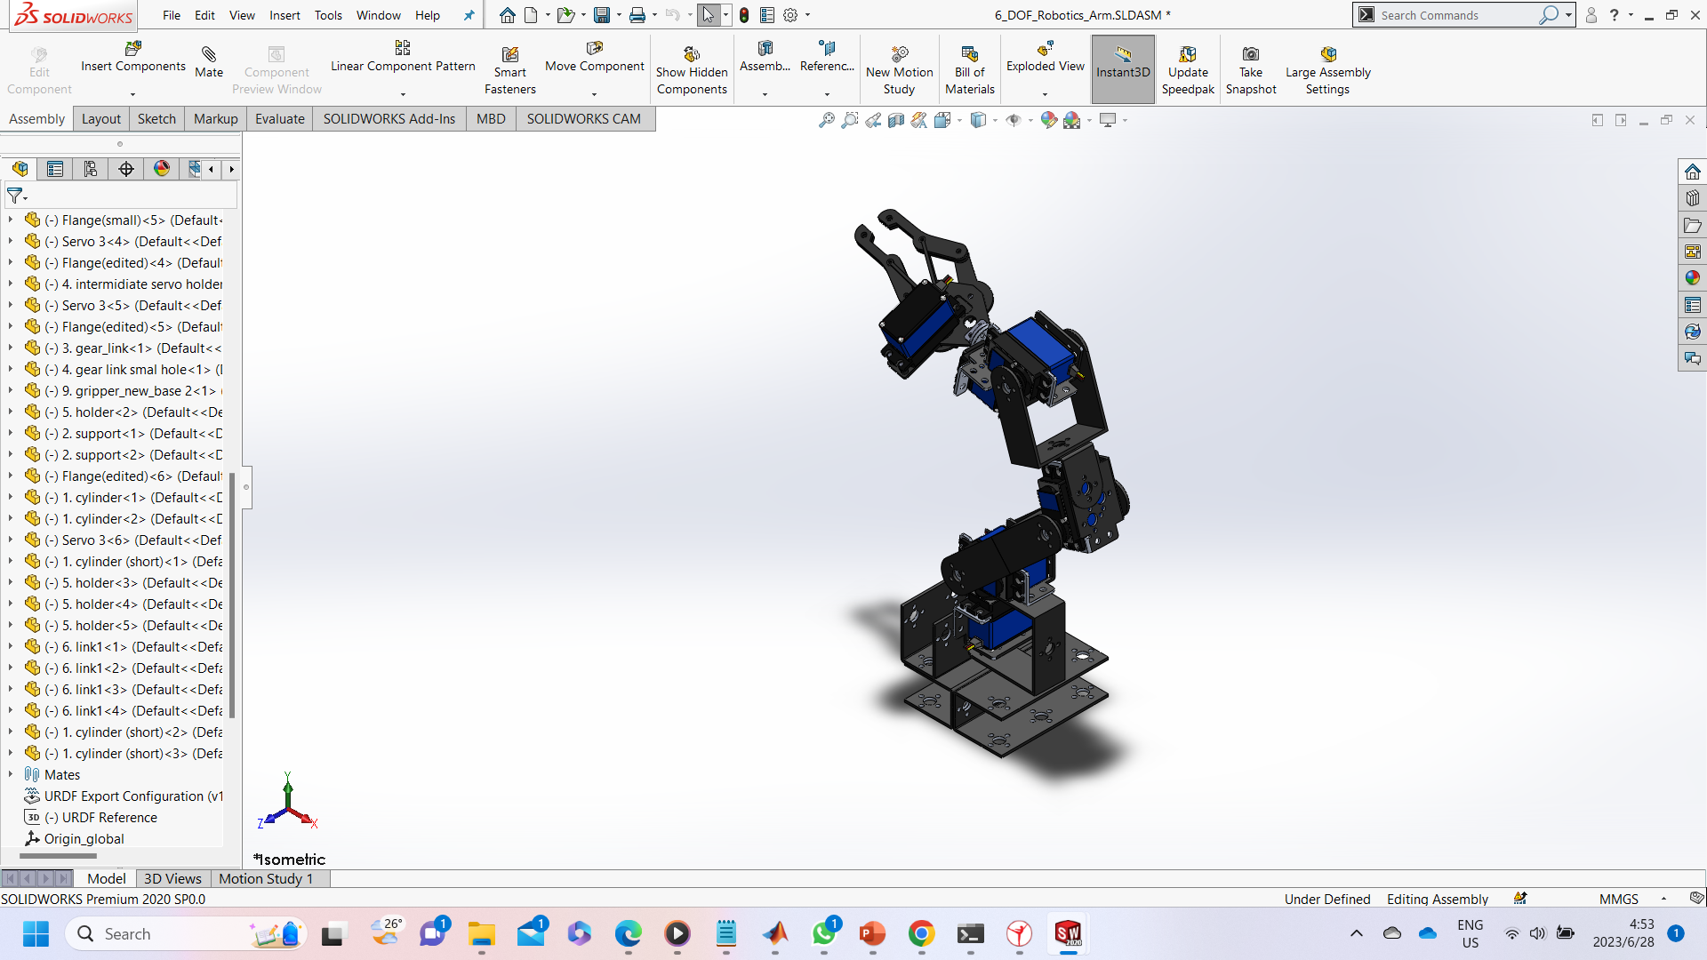

Figure 1: Robotic Arm in SolidWorks

3.4 Universal Robot Descriptions File (URDF)

The Universal Robot Description File (URDF) is an XML-based file format used to describe the structure, kinematics, and visual representation of a robot model. The robotic arm is designed by using SolidWorks and is exported as URDF by using the SolidWorks to URDF plugin available.

A hierarchical structure is defined in URDF which representing the kinematic chain of a robot. In this case, the base link is referred to a global coordinate, which is the parent link. The parent link provides the reference frame for the child link, determining its position and orientation relative to the parent. The respective parts which are related to the links and joints is selected and defined accordingly. Finally, a link tree and joint tree are obtained and shown in figure 2 and figure 3 respectively.

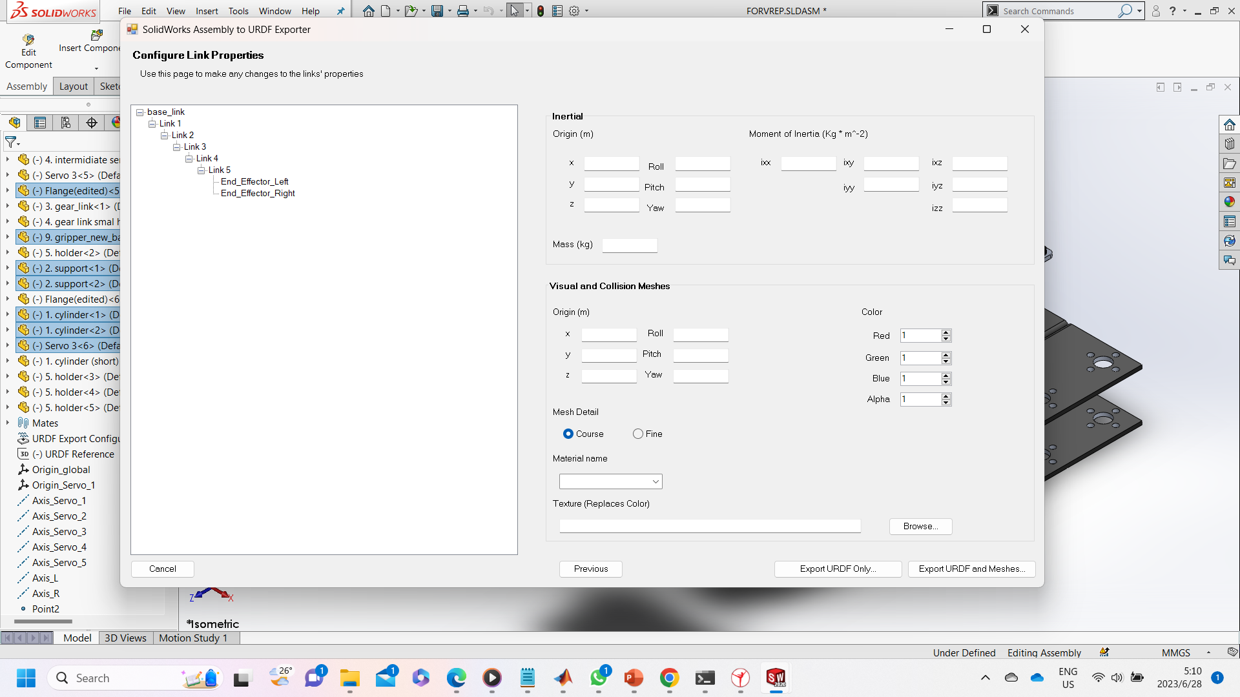

Figure 2: Link Tree of the System

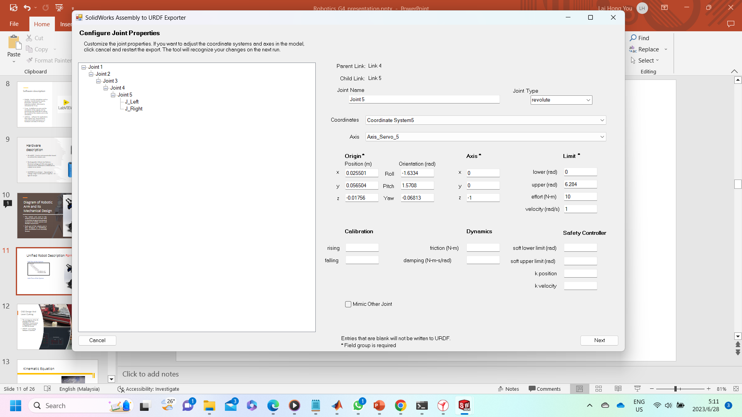

Figure 3: Joint Tree of the System

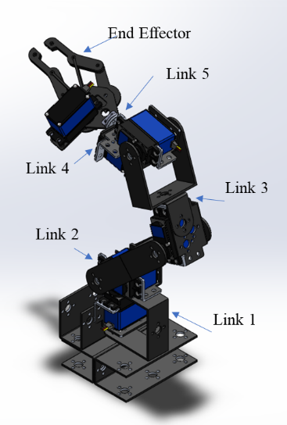

Figure 4: Annotated Robotic Arm in SolidWorks

The properties of the joints are configured after the system’s link tree has been defined. Various types of joints can be defined in URDF. In this case all the joints are revolute. The origin and axis of each part in the assembly are predefined in the SolidWorks, referencing the position and orientation of the links and joints. The plugin parameters are followed directly from the SolidWorks.

The URDF file encapsulates the entire robot description. It contains information such as the robot's name, its reference coordinate system and axis, relationship of the parent link and child link, and the units of measurement used in the file. Once the URDF of the designed robotic arm is created, the designed robotic arm can be imported to V-REP platform to carry out the simulation.

3.5. Robot Control and Movement

3.5.1 Control Design

To control the movement of the robotic arm in V-REP using MATLAB, V-REP remote API functions is used together with a main code. These functions establish a connection between MATLAB and V-REP, enabling to control and interact with the simulation environment from MATLAB. MATLAB functions is used to send commands to V-REP perform simulations by simulate the situation of transplanting seedling from one location to another.

3.5.2 Flow Chart

Figure 5 illustrates the flow chart for the overall working principle or operation of the robotic pick and place mechanism. The robot is designed to improve the precision of plant phenotyping for breeders to make informed decisions to meet the demands of modern agriculture and to contribute to resilient and sustainable crop production.

The sample is located on the floor. Once the infrared ray sensor detects the sample. The robotic arm equipped with a gripper will approach the sample with opened gripper. The gripper will close to grip the sample upon reaching and lift the sample. Then, the robotic arm brings the sample to the front and open the gripper to drop it into a container. Next, the gripper will grip the container and place it beside the robotic arm. The gripper opened and returned to rest position.

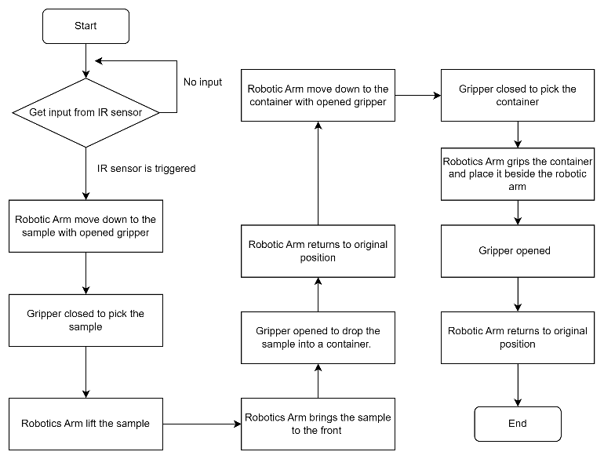

Figure 5: Flow Chart of Robot Motion

4. Result demonstration

*4.1.1 Simulation*

Through simulation using V-rep and MATLAB, only the movement of 6DOF Robotic Arm is able to move as expected. But in the simulation video, the square sample is not able to lift. This is due to the insufficient gripping force. The robotic arm has not enough gripping force and appropriate gripper mechanism to securely hold and lift the object. In real-life, the gripper is good enough pick and place the sample due to the sample’s light weight and soft body.

The main purpose of this robot is to study and design an automated robotic arm to improve the precision of plant phenotyping. Without the assistance of robotics arm, collection of data would necessitate manual efforts across multiple crops, with measurements then extrapolated for the entire farm. The robotic arm can replace the manual crop measurements which are labour-intensive, time consuming and susceptible to errors.

After the infrared ray sensor detects the sample, the sample will be gripped and dropped into the container. After successfully dropping the sample, the container will be gripped and moved to the position next to the robotic arm. The robotic arm will then return to its original position. The gripper and robotic arm’s motion are done by adjusting the angle of the relative joints in MATLAB.

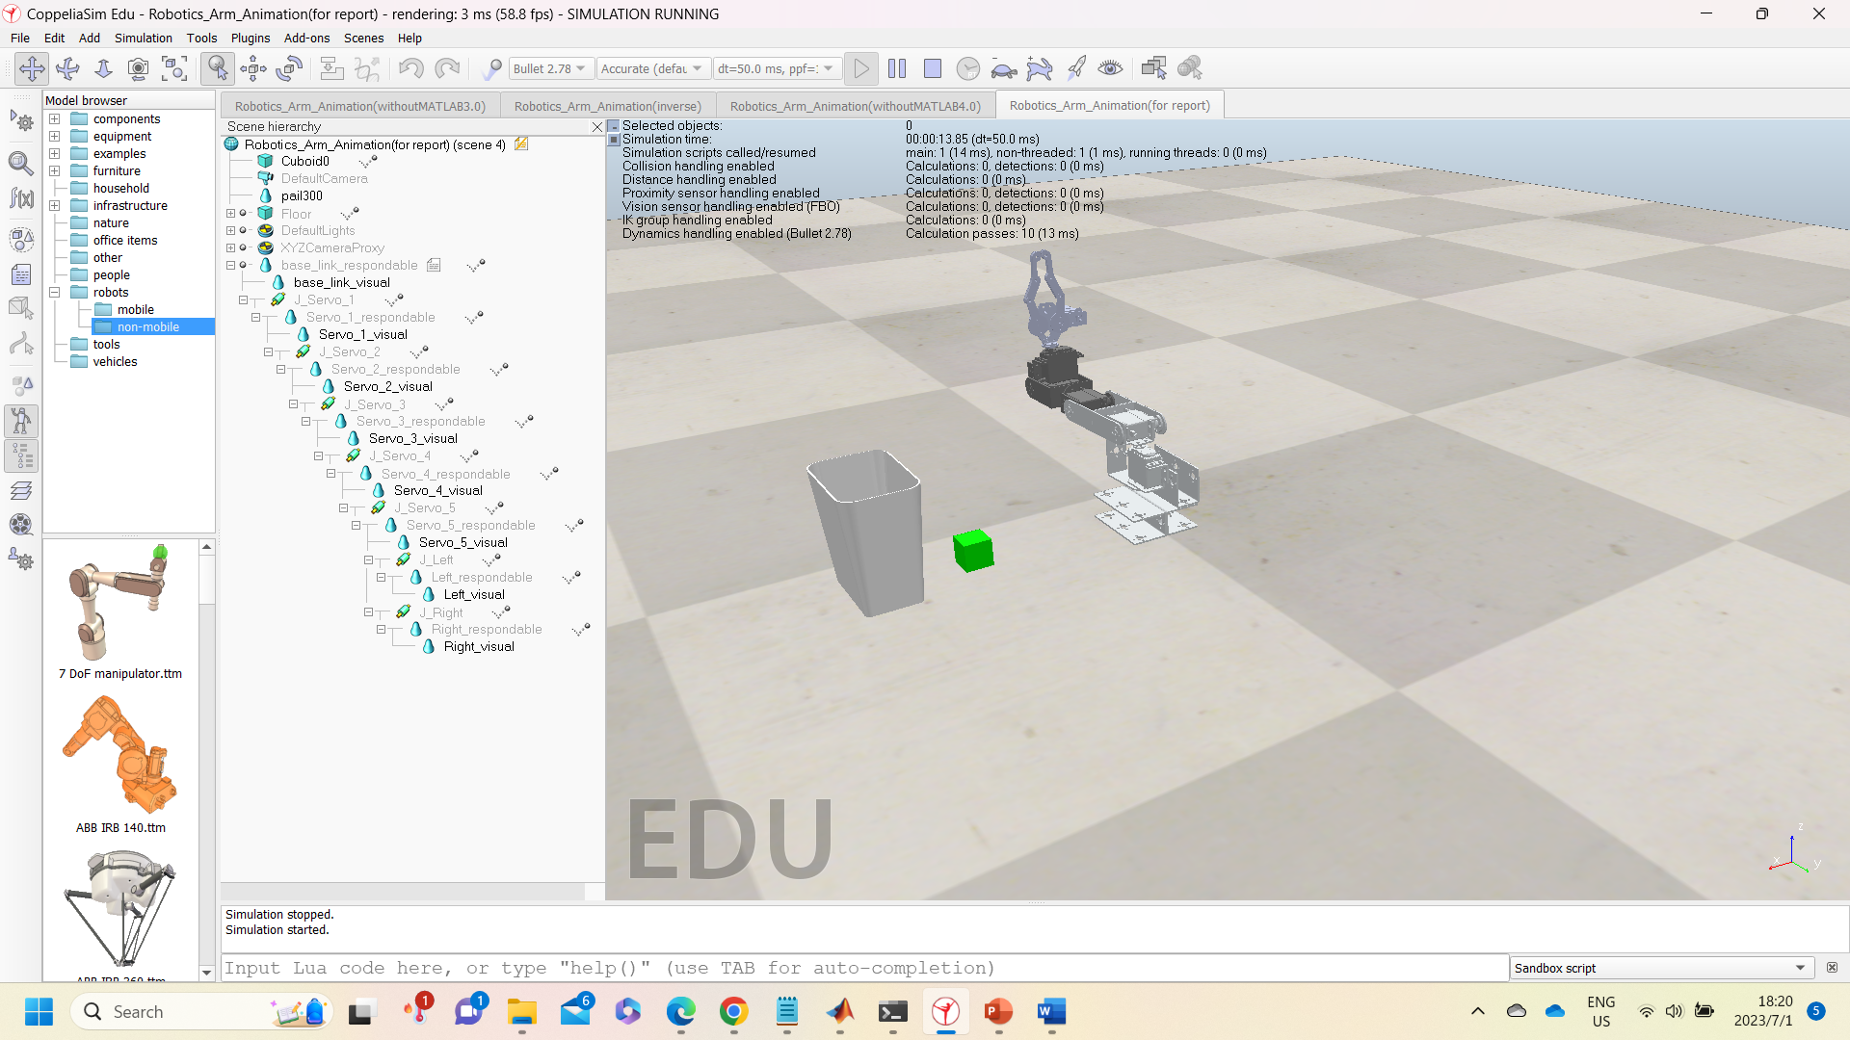

*Figure 6: Robotic Arm at Its Initial Position*

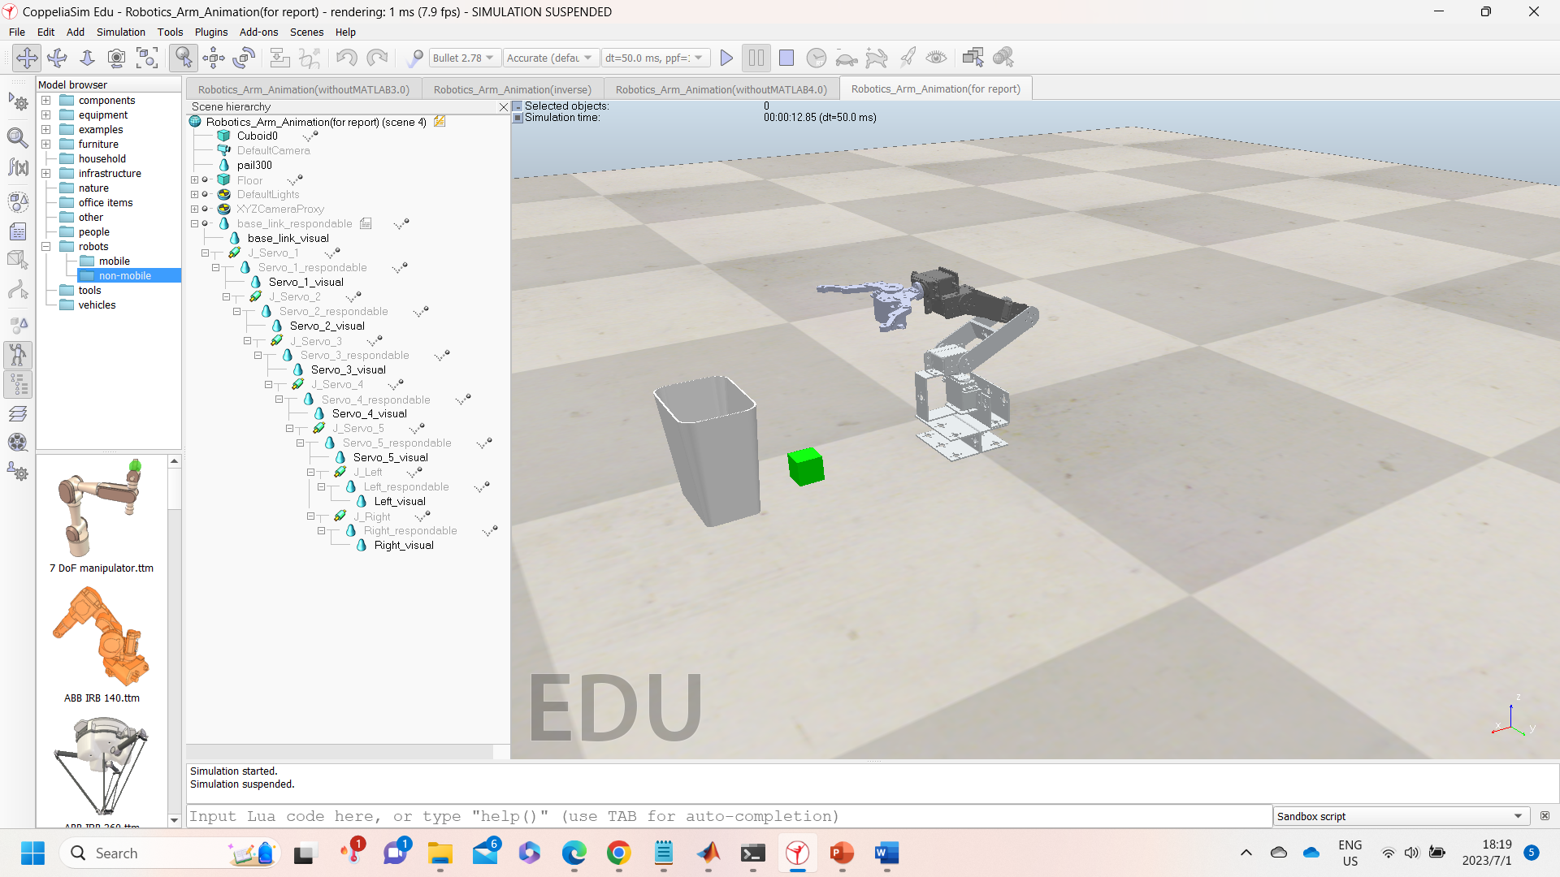 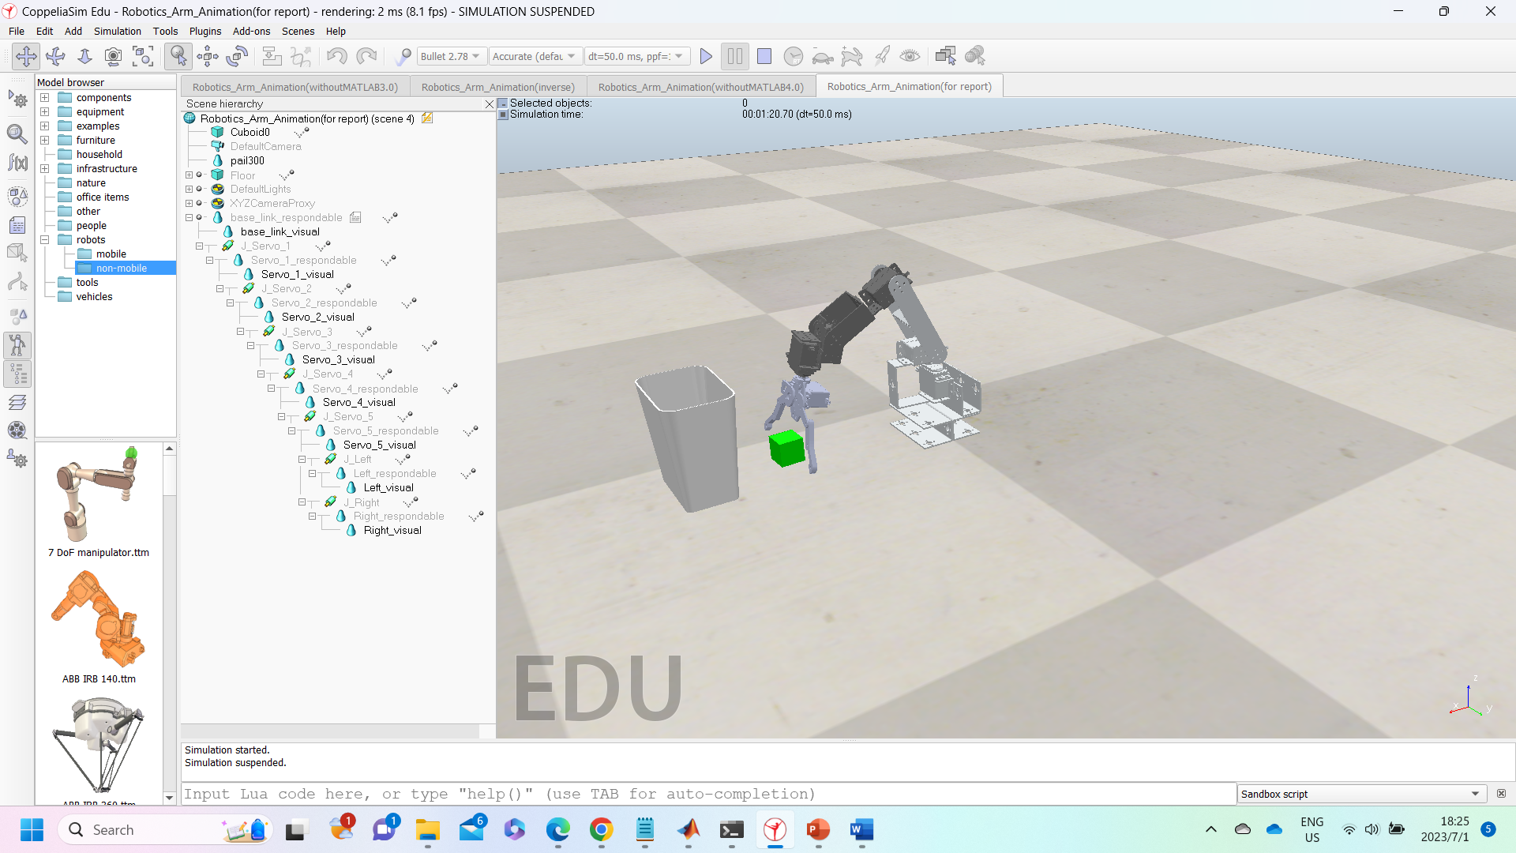

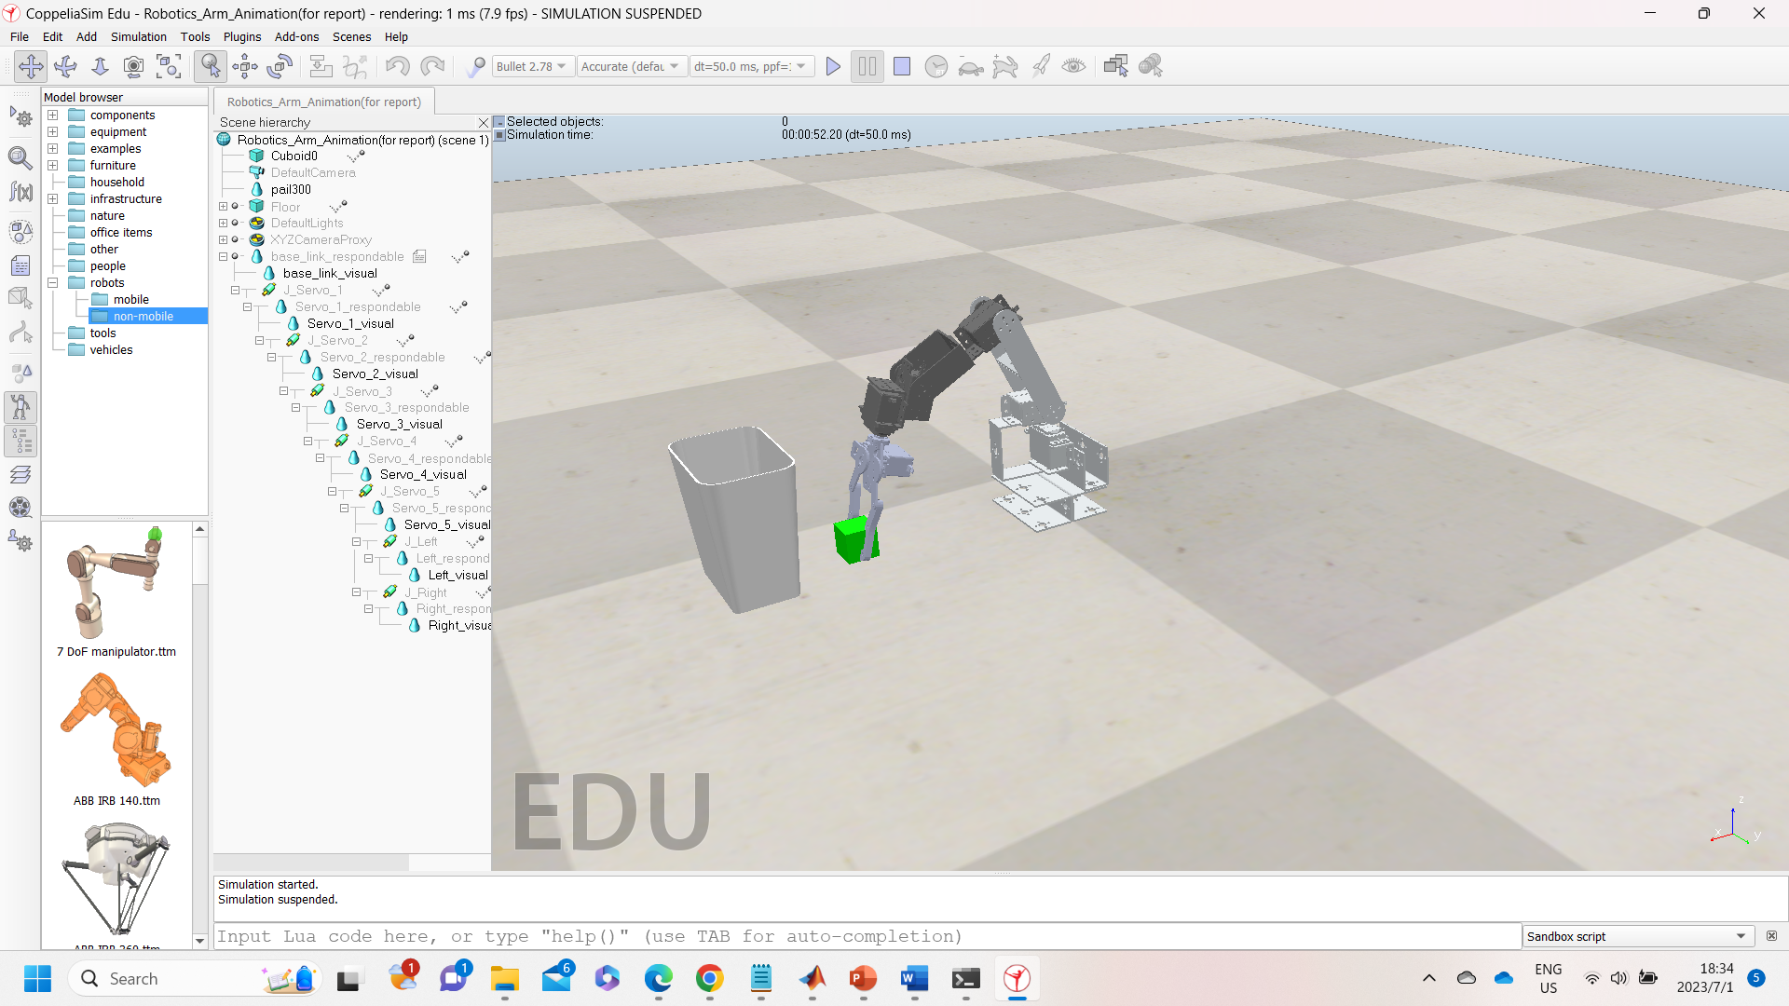 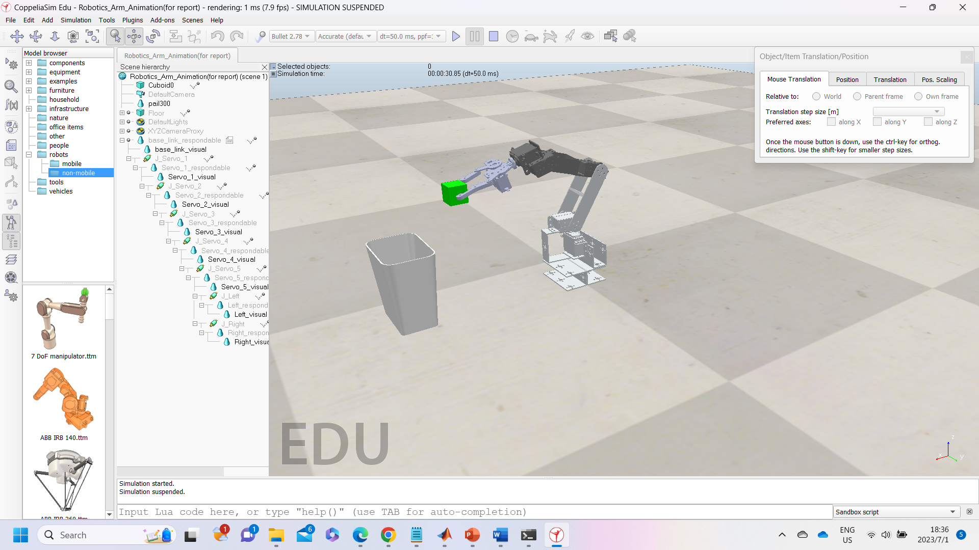

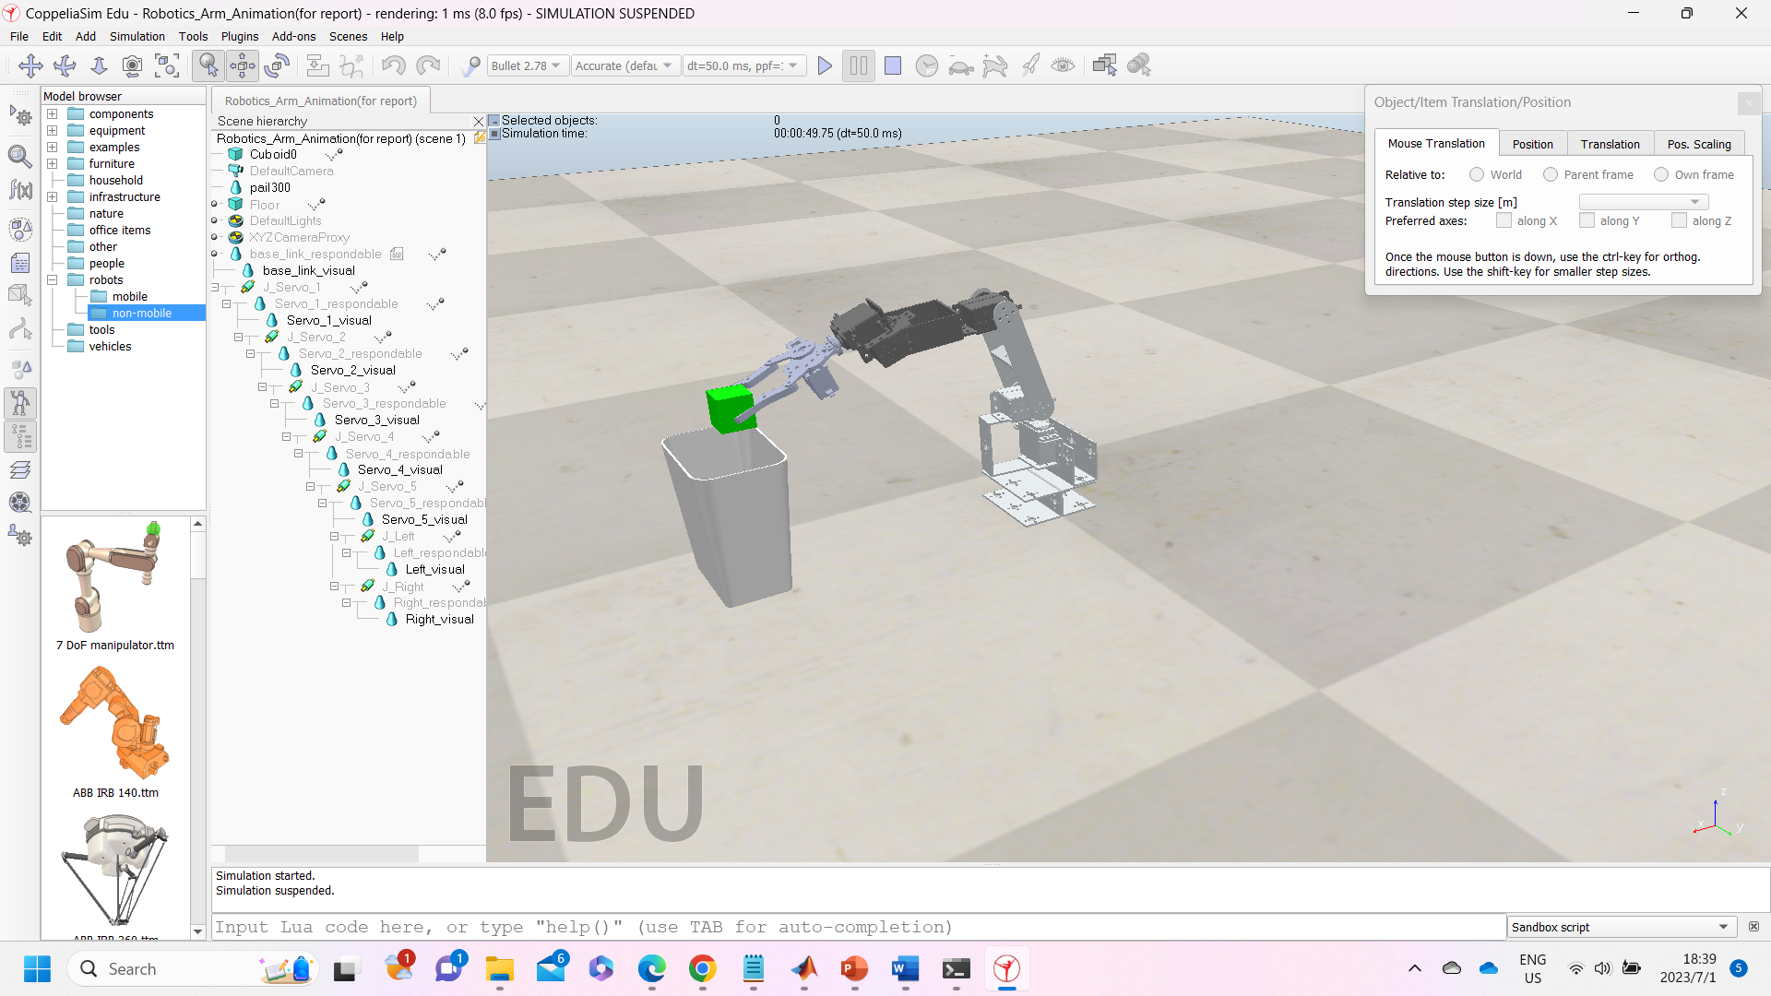 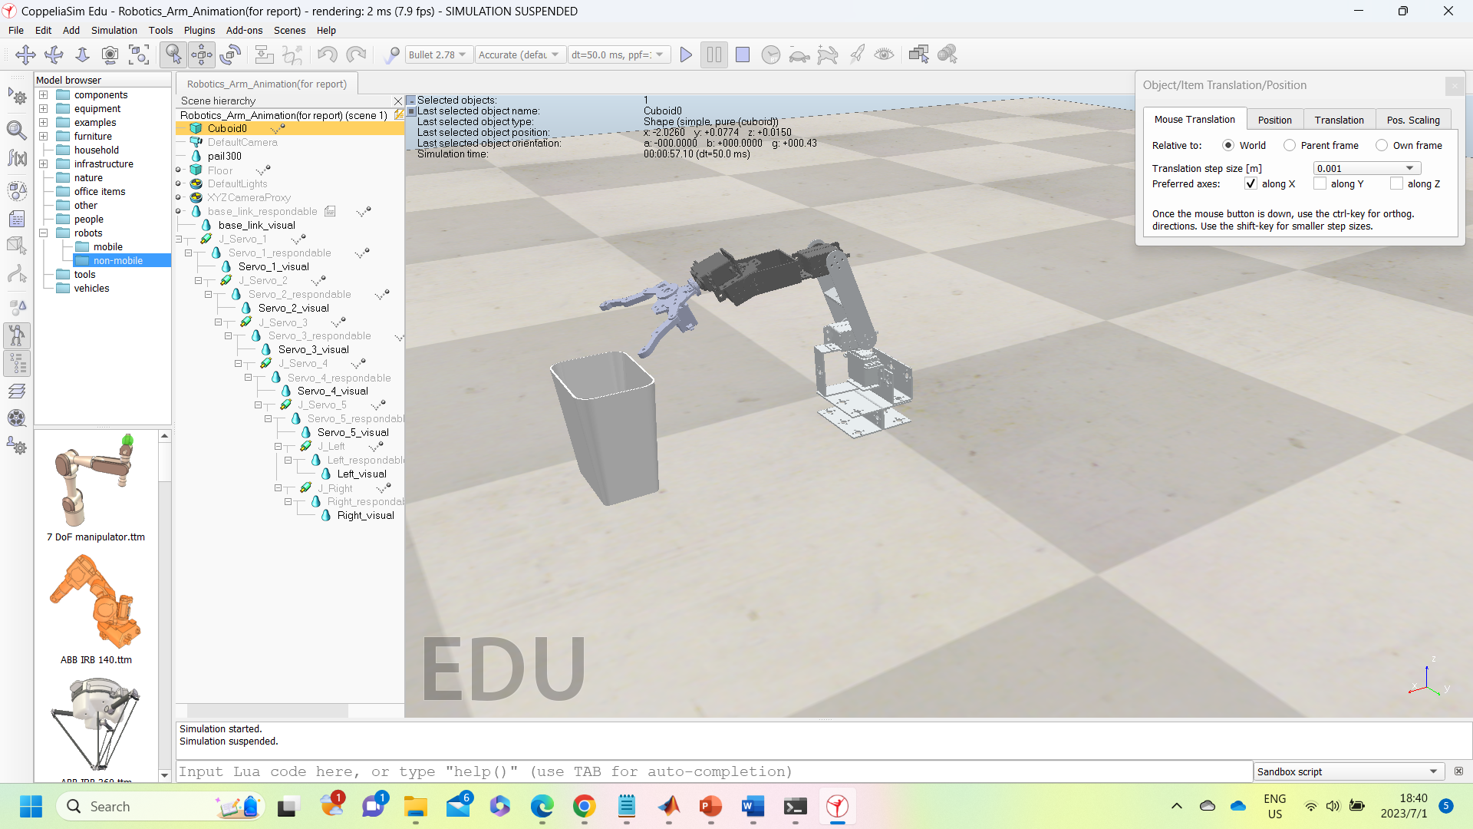

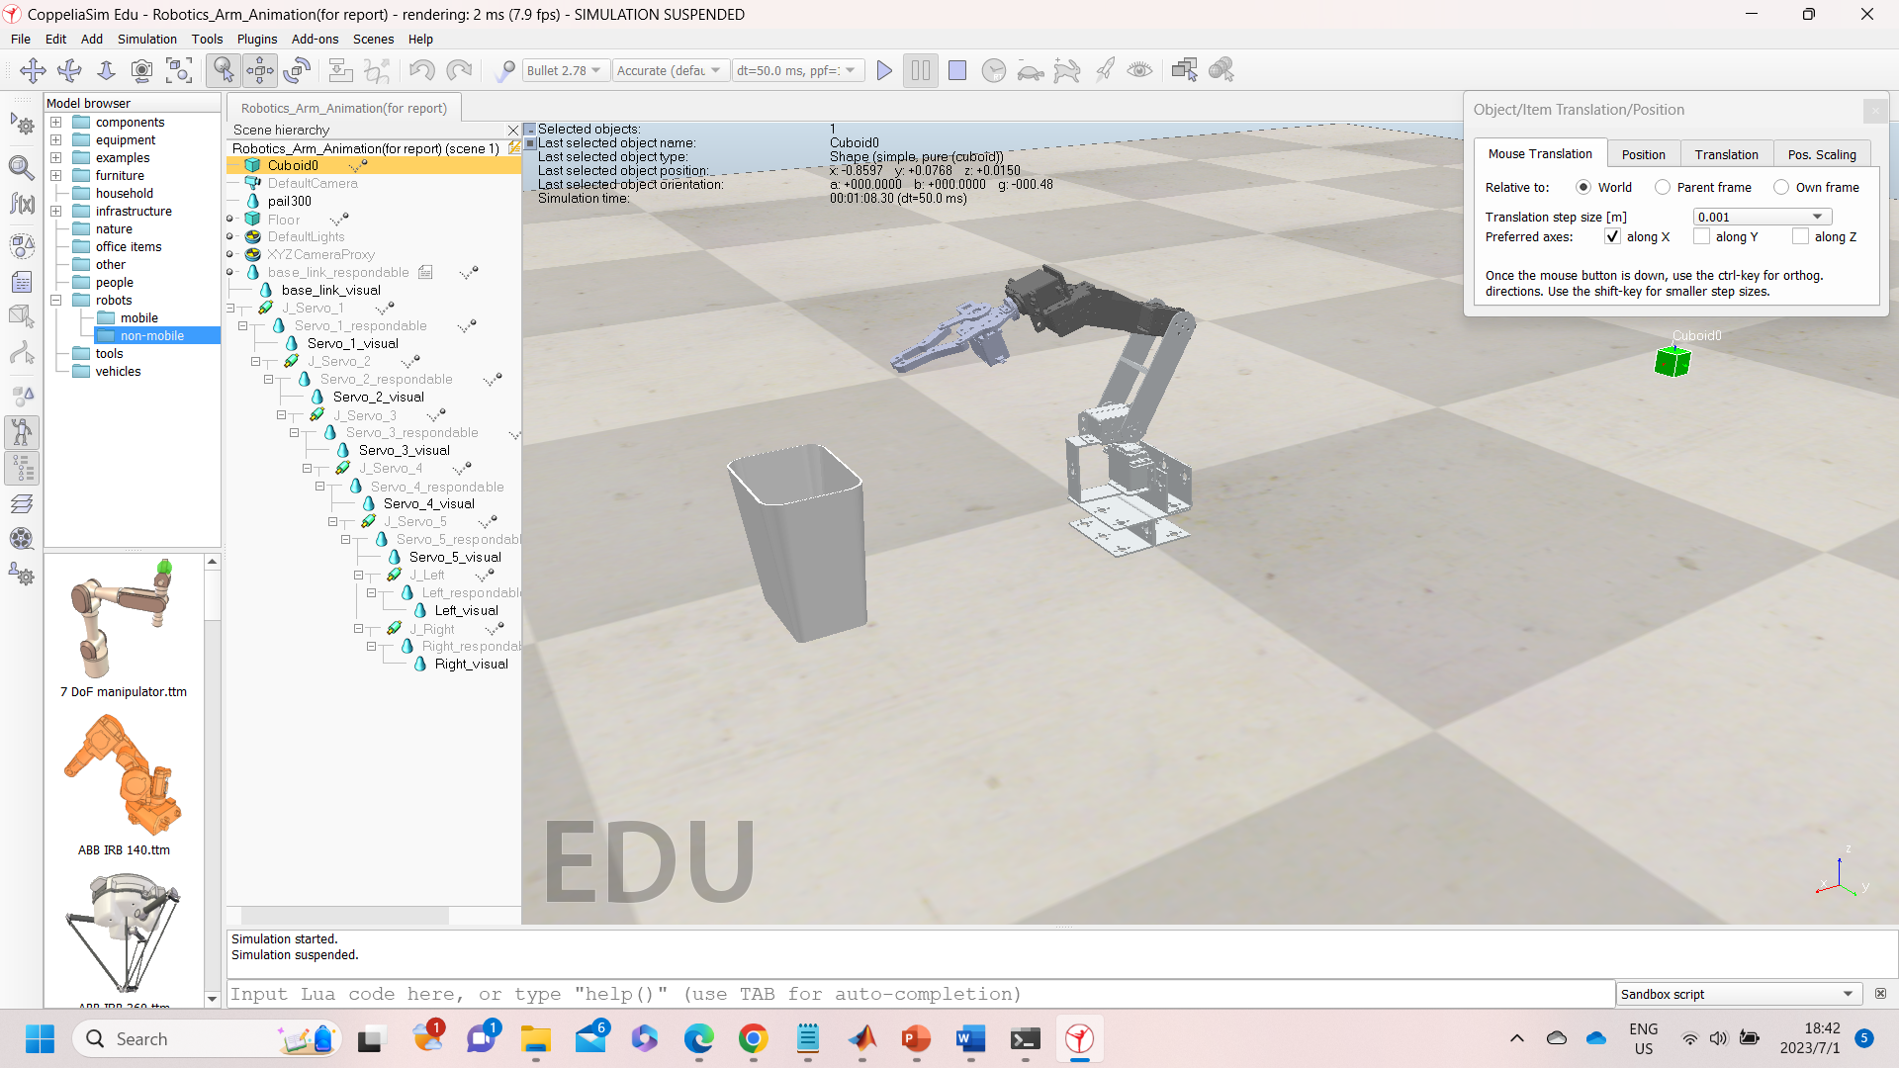 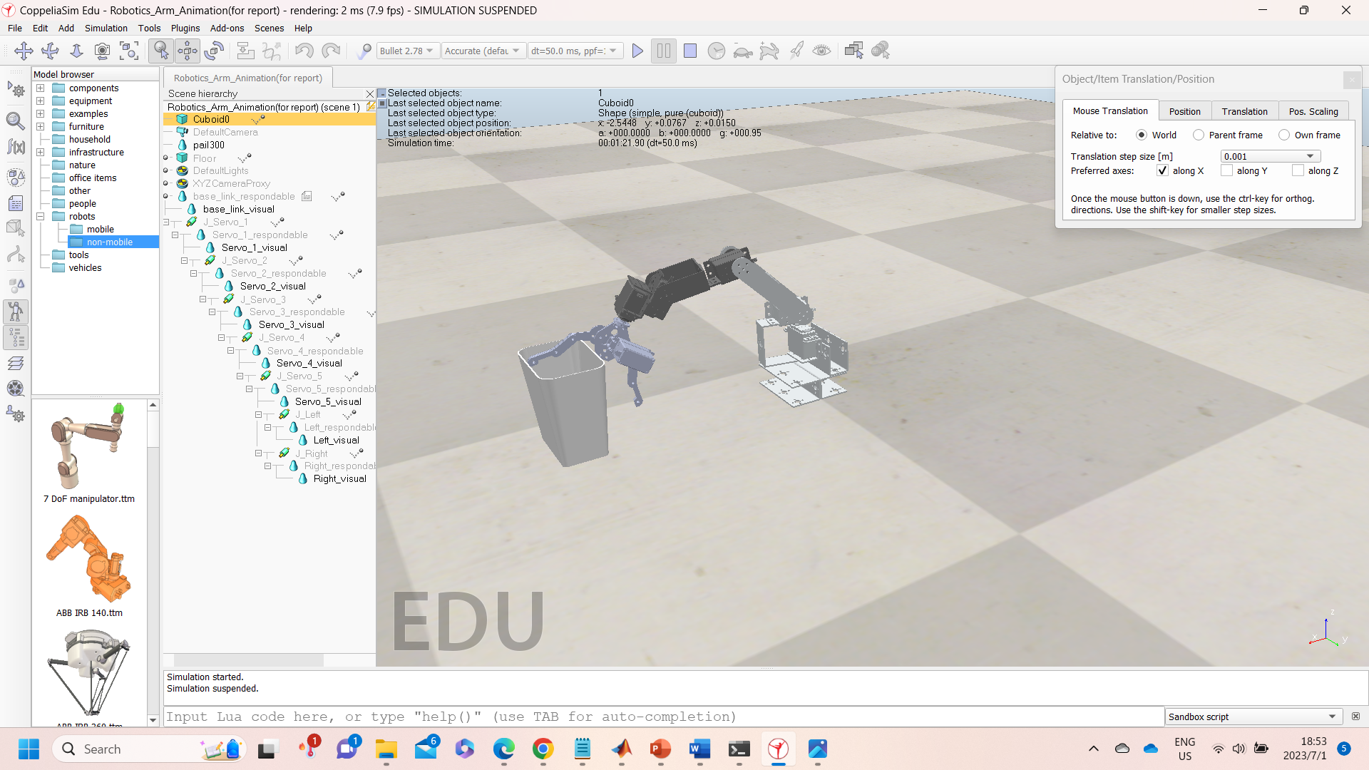

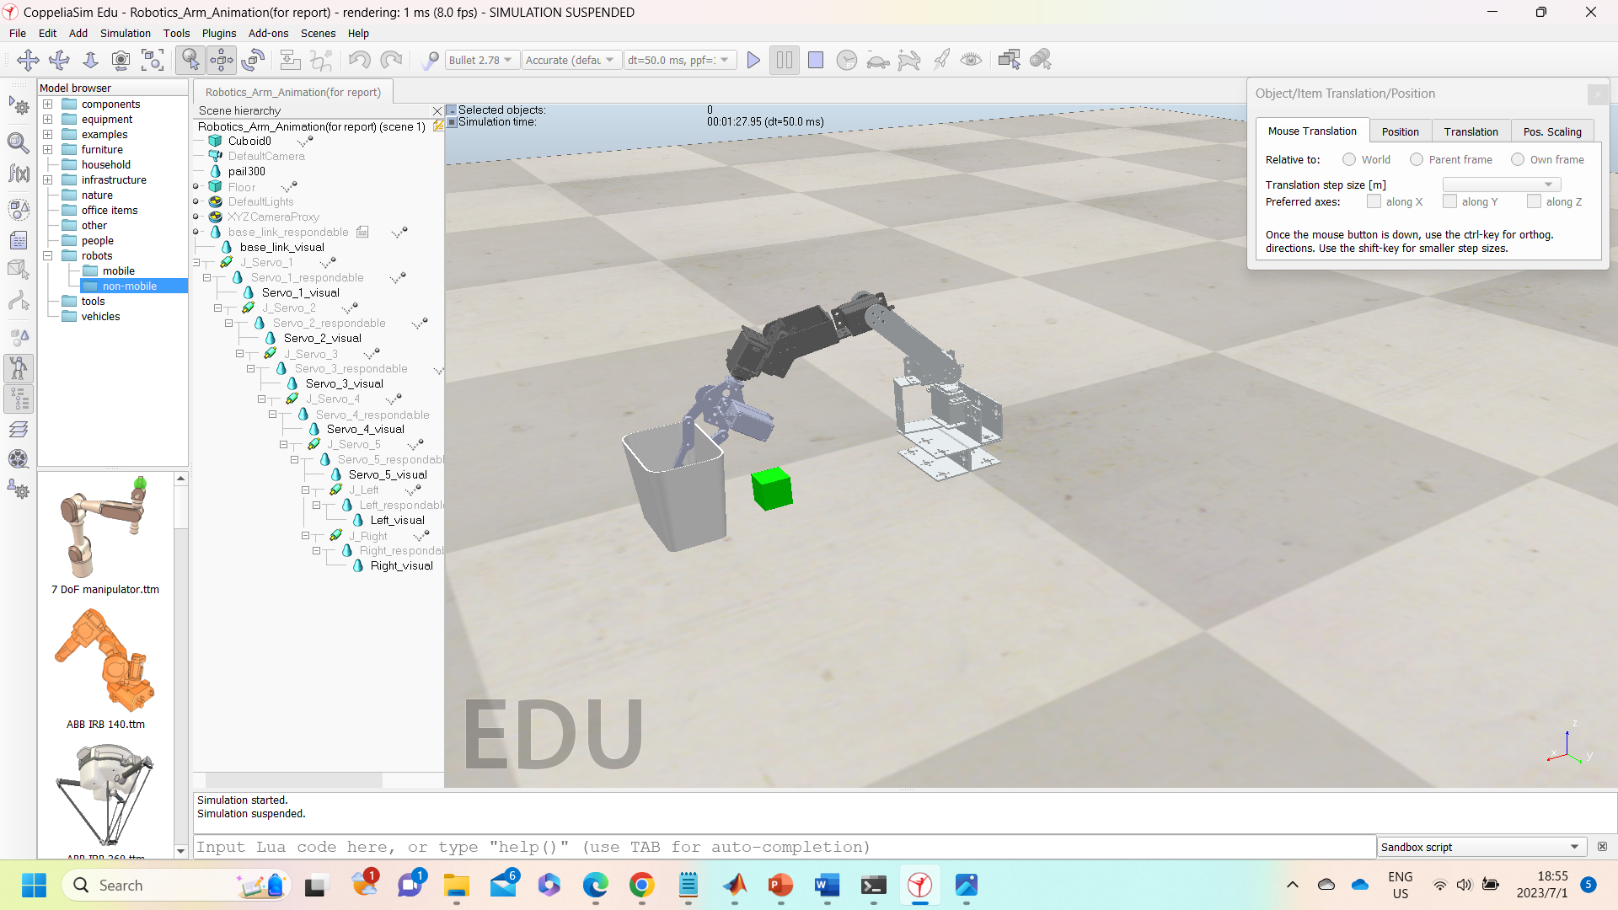 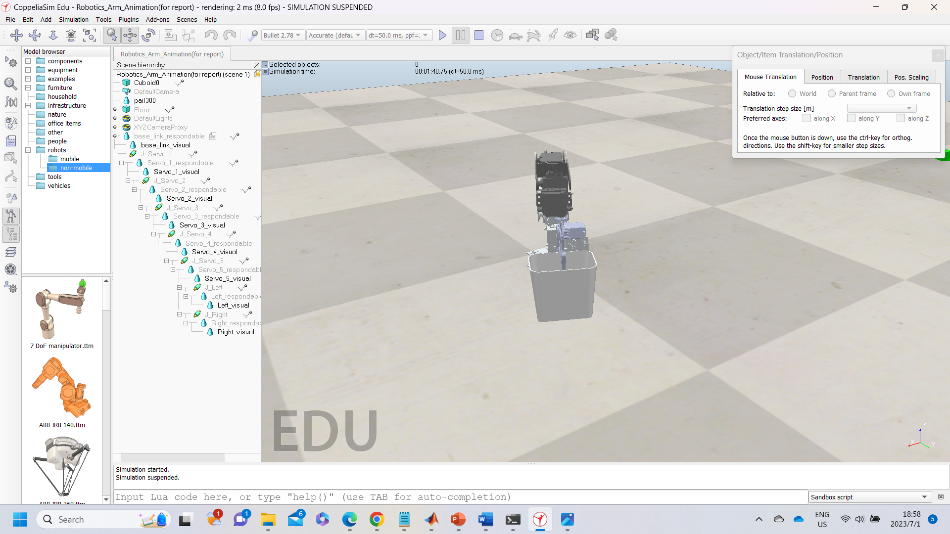

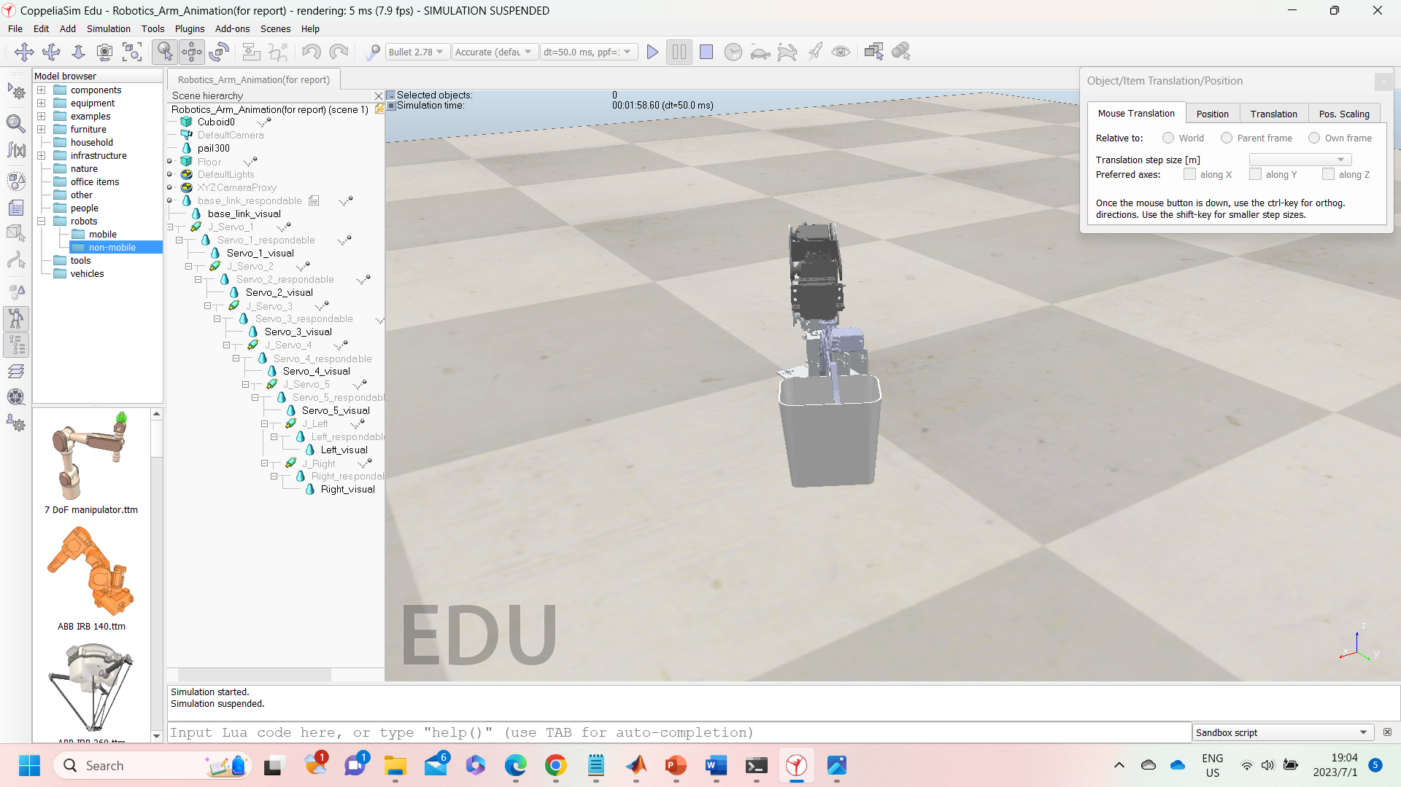 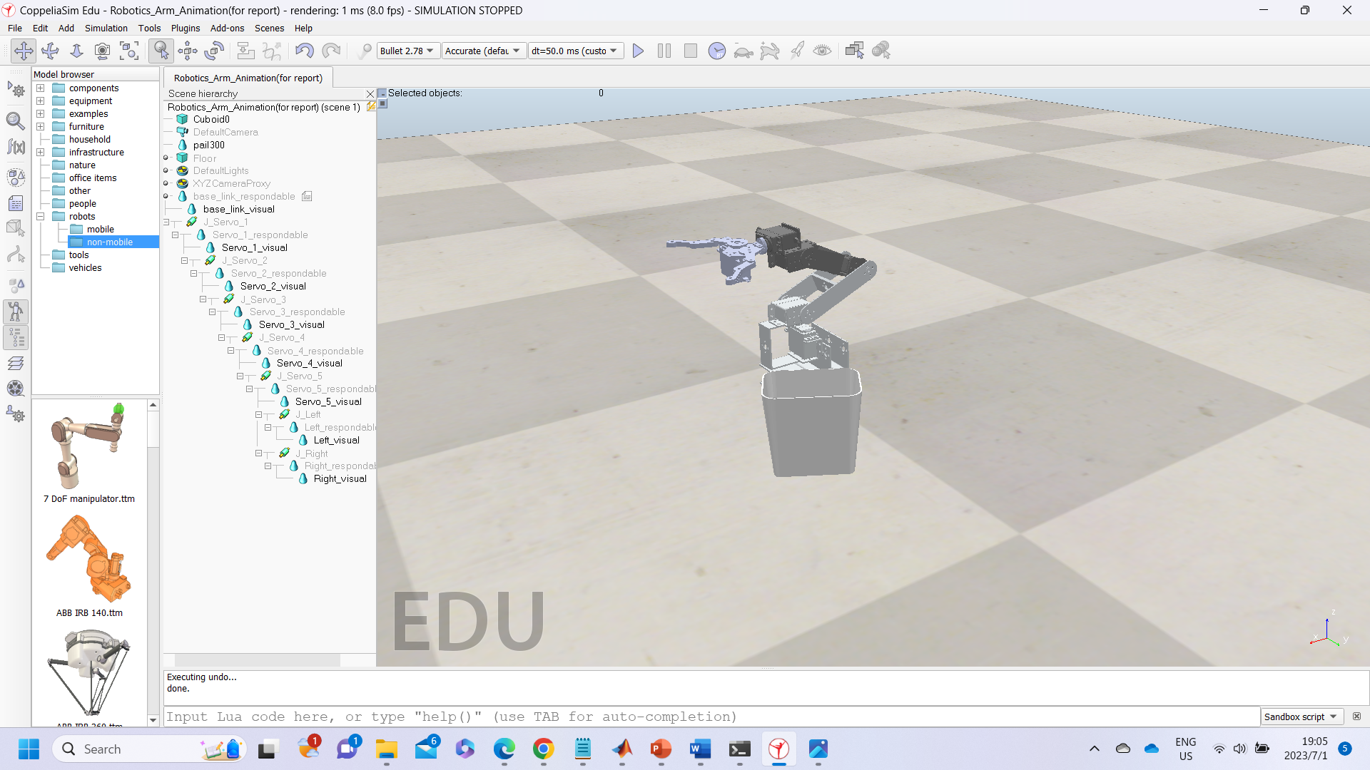

*Figure 7: Movement of the Robotic Arm*

*4.1.2 LabVIEW Control*

The MyRIO controller is programmed by using LabVIEW, where the integration of fully manual mode, semi-autonomous mode and the monitoring system and live view camera are integrated during the development process. The LabVIEW was programmed with the idea of a development tool. After deriving the Jacobian matrix and inverse kinematic, the calculated result could be used to input into the LabVIEW to validate the result. After the results are validated, the joint-space variables could then be recorded into the algorithm programmed. The motion sequence tester is to test the motion smoothness of the robotic arm before integrating into autonomous mode.

The verified motion sequence is then recorded in the program, and it is set to be triggered either by sensor or monitoring system using LabVIEW. The sensor point recorded the location of the target. The action is triggered when the sensor senses phenotypes to be collected. The simple sensor is used to demonstrate the process of collecting the phenotypes which is then replaced by the camera and the image processing algorithm in the future for fully autonomous mode.

This is the user interface, **LabVIEW Front Panel**

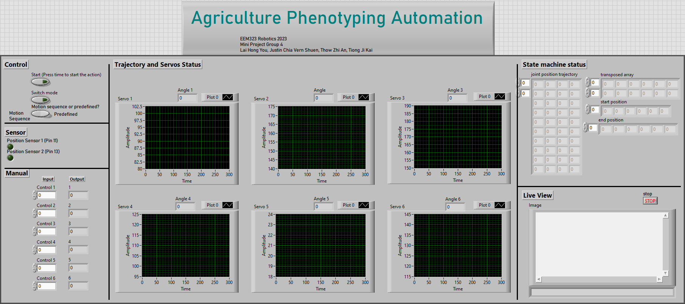

Figure 8: LabVIEW Front Panel

The LabVIEW block diagram are illustrated as below.

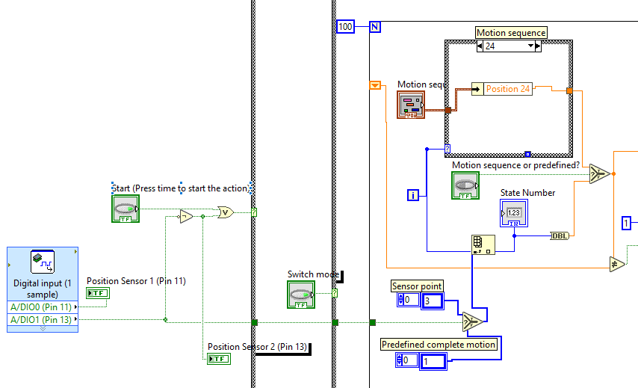

Figure 9: LabVIEW Block diagram part 1

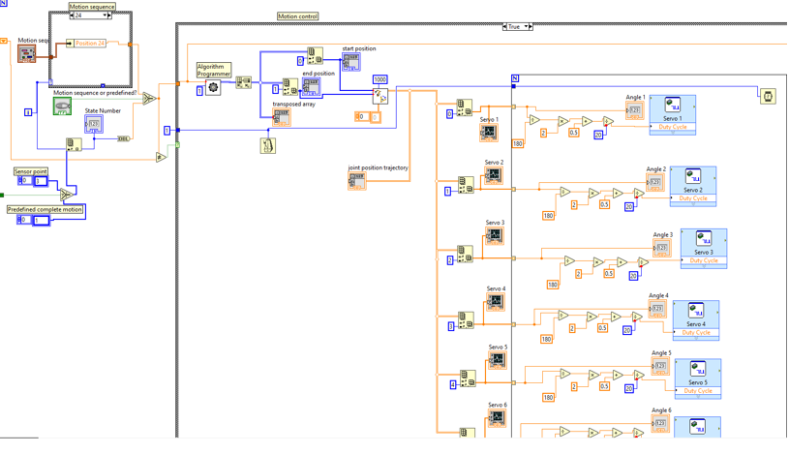

Figure 10: LabVIEW Block diagram part 2

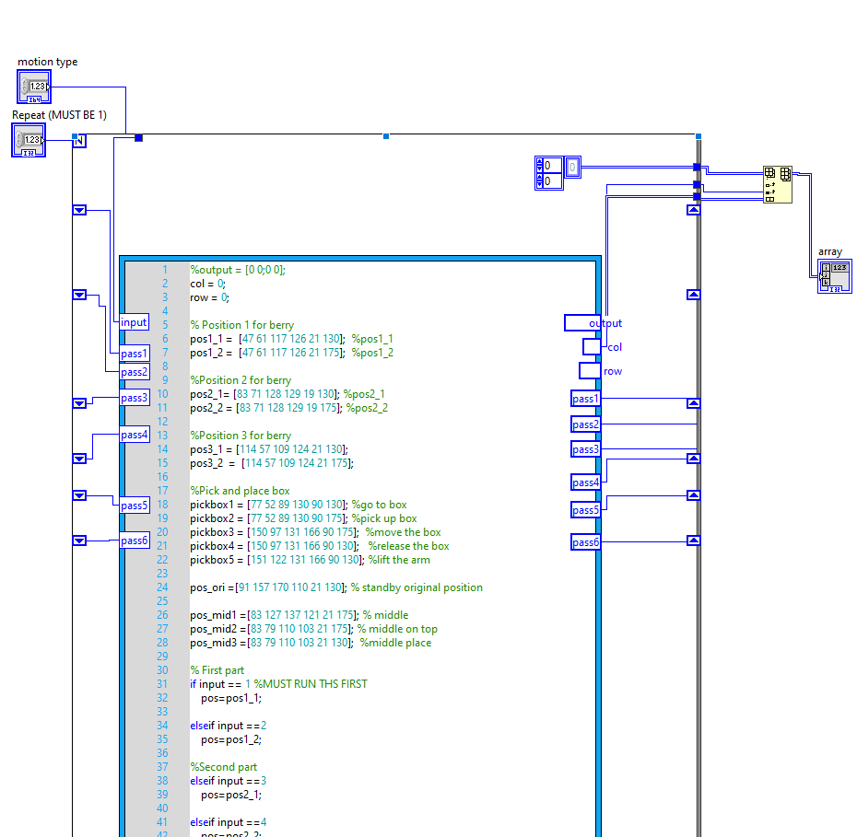

Figure 11: LabVIEW Block diagram part 3

*4.2 Kinematic Equation Analysis*

*4.2.1 Forward Kinematic Equation*

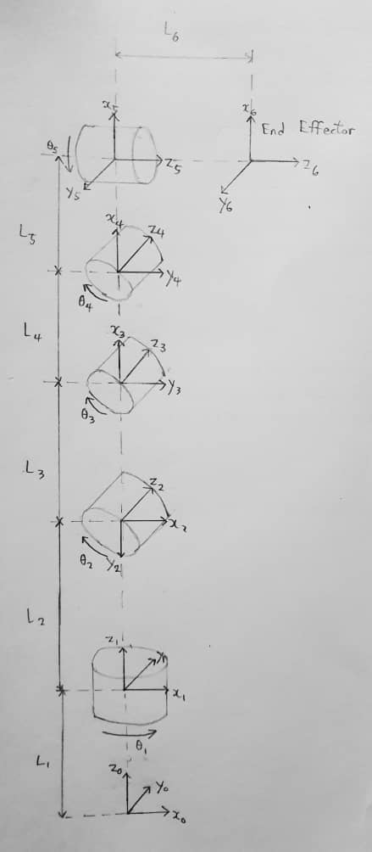

Figure 12: Skeleton diagram of robotic arm

Table 1: DH table of robotic arm

|  |  |  |  |  |
| --- | --- | --- | --- | --- |
| Links | αi | ai | di | θi |
| 0 – 1 | 0 | 0 | L1 | 0 |
| 1 – 2 | -90 | 0 | L2 | θ1 |
| 2 – 3 | 0 | L3 | 0 | θ2 |
| 3 – 4 | 0 | L4 | 0 | θ3 |
| 4 - 5 | -90 | L5 | 0 | θ4 |
| 5 - 6 | 0 | 0 | L6 | θ5 |

Figure 8 shows skeleton diagram of robotic arm while Table 1 shows DH parameters of the robotic arm. Transformation matrices are calculated with the DH parameters obtained. Then, forward kinematic equation is calculated and use to calculate Jacobian of robotic arm.

**Transformation Matrices**

0T1=

1T2 =

2T3 =

3T4 =

4T5 =

5T6 =

Forward Kinematic Equation, 0T6

0T6 =

*4.2.2 Jacobian Equation*

$\left[\begin{matrix}s_{12}s_{6}+c_{6}(c_{12}c_{34}c_{5}-c_{12}s_{34}s_{5}) & -c_{12}s_{345} & s_{6}(c_{12}c_{34}c_{5}-c_{12}s_{34}s_{5})- s_{12}c_{6} & c_{12}({L_{3}c_{3}-L_{5}s_{345}+L}_{4}c_{34}) \\ c_{6}(s_{12}c_{34}c_{5}-s_{12}s_{34}s_{5})- c_{12}s_{6} & -s_{12}s_{345} & c_{12}c_{6}+s_{6}(s_{12}c_{34}c_{5}-s_{12}s_{34}s_{5}) & s_{12}({L_{3}c_{3}-L_{5}s_{345}+L}_{4}c_{34}) \\ -s_{345}c_{6} & -c_{345} & -s_{345}s_{6} & L_{1}+L_{2}-L_{4}s_{34}-L_{5}c_{345}-L_{3}s_{3} \\ 0 & 0 & 0 & 1\end{matrix}\right]$

Table 2: Jacobian of robotic arm

|  |  |  |  |
| --- | --- | --- | --- |
|  | dx | dy | dz |
| θ1 |  |  | 0 |
| θ2 |  |  |  |
| θ3 |  |  |  |
| θ4 | ) | ) |  |
| θ 5 |  |  |  |

=

=

=  )

= + +

*4.2.3 Inverse Kinematic Equation*

In a 6-degree-of-freedom (DOF) robotic arm, the inverse kinematics process is similar to that of a 5-DOF arm, where the rotation of the wrist has minimal impact on the overall solution.

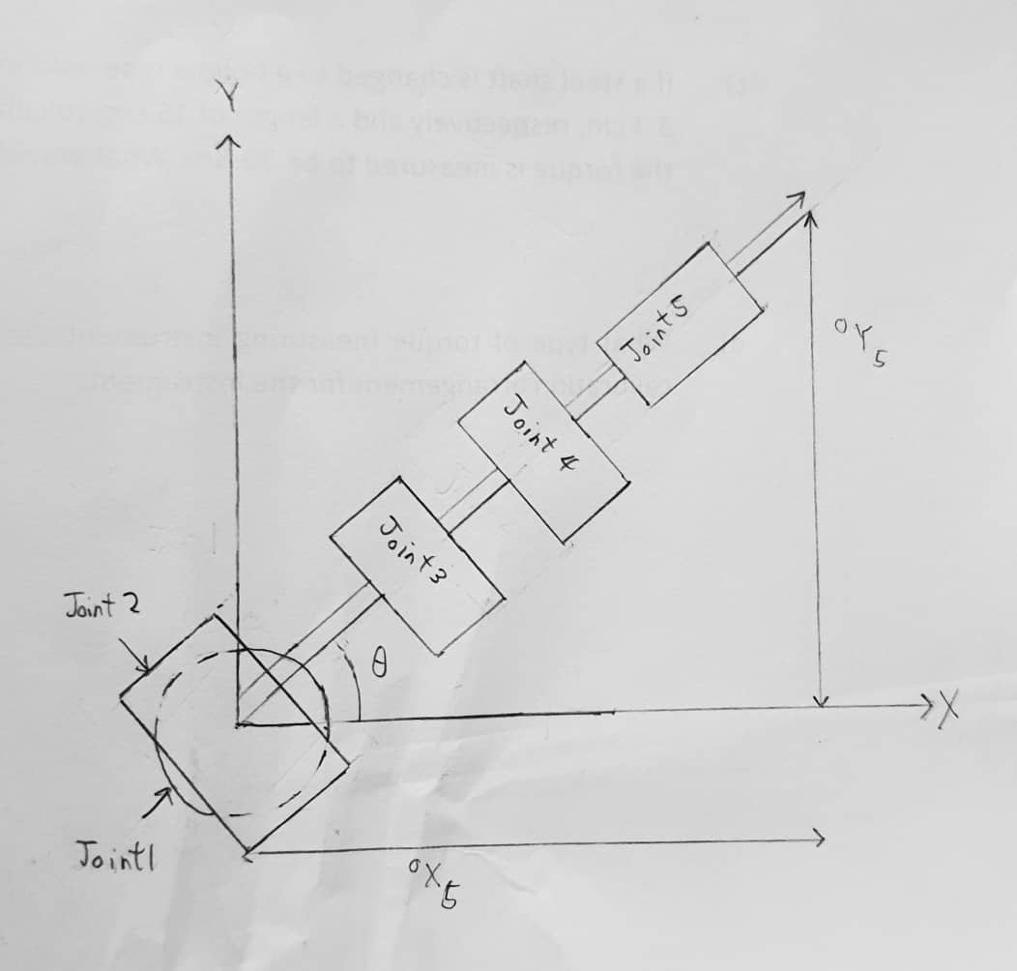

Figure 13: Top view of robotic arm

From top view of robotic arm,

$θ$ = $\tan^{-1}{\frac{ ^{0}Y_{5}}{ ^{0}X_{5}}}$

r = $\sqrt{{{ ^{0}X_{5}}^{2}{+ }^{0}Y_{5}}^{2}}$

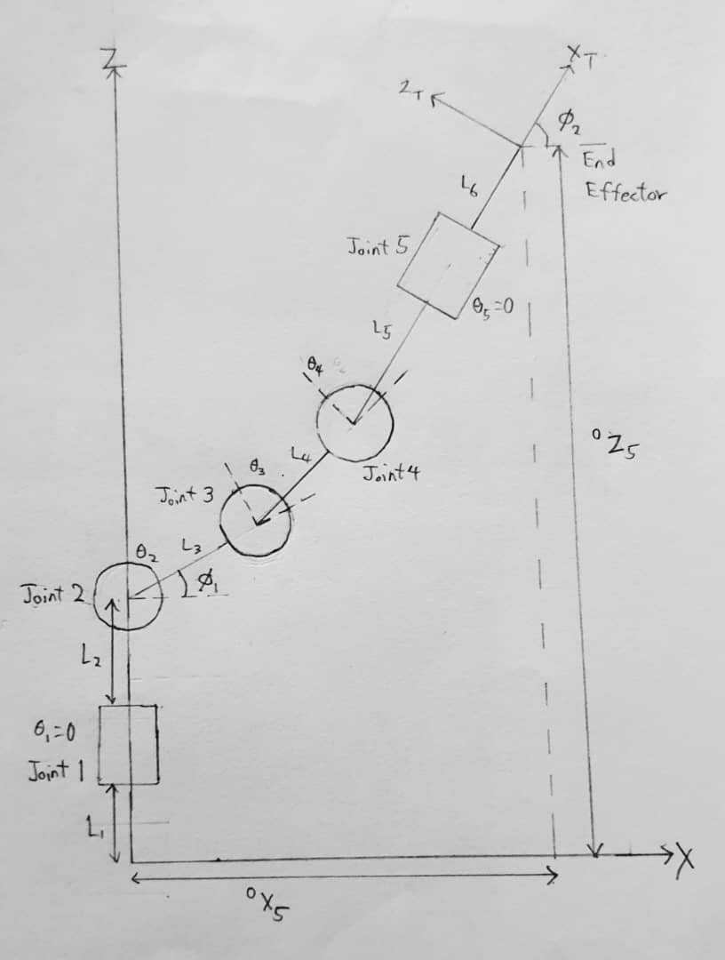

Figure 14: Side view of robotic arm

Φ2 = (90˚ θ2) + (90˚ θ3) + (90˚ θ4)

= 270˚ θ2 – θ3 – θ4 -----Eq1

*l*24x = -----Eq2

*l*24x =

*l*24x = -----Eq3

*l*24z = -----Eq4

*l*24x =

*l*24x = -----Eq5

Eq22 + Eq42 = Eq32 + Eq52

()2 + ()2

=[ ]2 + ]2

()2 + ()2

= + + 2[] + 2[]

()2 + ()2

= + + 2[]

()2 + ()2

= + 2[]

()2 + ()2

= + 2

2

= ()2 + ()2 - -

=

= +

tan = =

=

= =

From Eq1,

θ4 = 270˚ θ2 – θ3 – Φ2

θ4 = 270˚ [] + ] Φ2

θ4 =

Φ2

*4.3 Dynamic Equation Analysis*

𝑇i = + 𝐼𝑖(𝑎𝑐𝑡) 𝑞̈𝑖 + + 𝐷𝑖

Where

𝐷𝑖𝑗 =

𝐷𝑖𝑗𝑘 =

𝐷𝑖 =

*And Inertia Matrix:*

*Ji*

a. Denavit-Hartenberg Parameters:

L1 = 0.10291 m, L2 = 0.10291 m, L3 = 0.09674 m, L4 = 0.03849 m, L5 = 0.01 m, L6 = 0.1025 m

Table 3: DH Parameters

|  |  |  |  |  |
| --- | --- | --- | --- | --- |
| Links | Αi | ai | di | θi |
| 0 – 1 | 0 | 0 | 0.10291 | 0 |
| 1 – 2 | -90 | 0 | 0.10291 | θ1 |
| 2 – 3 | 0 | 0.09674 | 0 | θ2 |
| 3 – 4 | 0 | 0.03849 | 0 | θ3 |
| 4 - 5 | -90 | 0.01 | 0 | θ4 |
| 5 - 6 | 0 | 0 | 0.1025 | θ5 |

b. Mass of each Link(Taken from SolidWorks’ Mass Property)

Link 1: m1 = 0.128kg

Link 2: m2 = 0.123kg

Link 3: m3 = 0.122kg

Link 4: m4 = 0.110 kg

Link 5: m5 = 0.092 kg

The general moment of inertia for each link is:

Ii =

Link 1:

I1 =

Link 2:

I2 =

Link 3:

I3 =

Link 4:

I4 =

Link 5:

I5 =

Derived dynamic equations are as follows:

T1 = D11 + D122 + D133 + D144 + D155 + D111+ D122+ D133+ D144+ D155+ 2 D112 + 2 D113 + 2 D114 + 2 D115 + 2 D123 + 2 D124 + 2 D125 + 2 D134 + 2 D135 + 2 D145 + D1

T2 = D211 + D222 + D233 + D244 + D255 + D211+ D222+ D233+ D244+ D255+ 2 D212 + 2 D213 + 2 D214 + 2 D215 + 2 D223 + 2 D224 + 2 D225 + 2 D234 + 2 D235 + 2 D245 + D2

T3 = D311 + D322 + D333 + D344 + D355 + D311+ D322+ D333+ D344+ D355+ 2 D312 + 2 D313 + 2 D314 + 2 D315 + 2 D323 + 2 D324 + 2 D325 + 2 D334 + 2 D335 + 2 D345 + D3

T4 = D411 + D422 + D433 + D444 + D455 + D411+ D422+ D433+ D444+ D455+ 2 D412 + 2 D413 + 2 D414 + 2 D415 +2 D423 + 2 D424 + 2 D425 + 2 D434 + 2 D435 + 2 D445 + D4

T5 = D511 + D522 + D533 + D544 + D555 + D511+ D522+ D533+ D544+ D555+ 2 D512 + 2 D513 + 2 D514 + 2 D515 + 2 D523 + 2 D524 + 2 D525 + 2 D534 + 2 D535 + 2 D545 + D5

Since the actual result is very long, it is calculated with MATLAB and saved in LinkTorqueCalculation.txt file.

*4.4 Trajectory Planning Analysis*

The purpose of trajectory planning for robotic arms is to determine the optimal path and motion sequence that enables the arm to reach a desired position or execute a specific task. It involves designing a continuous and smooth trajectory, considering the physical limitations of the robot, such as joint angles, joint velocities, and joint accelerations.

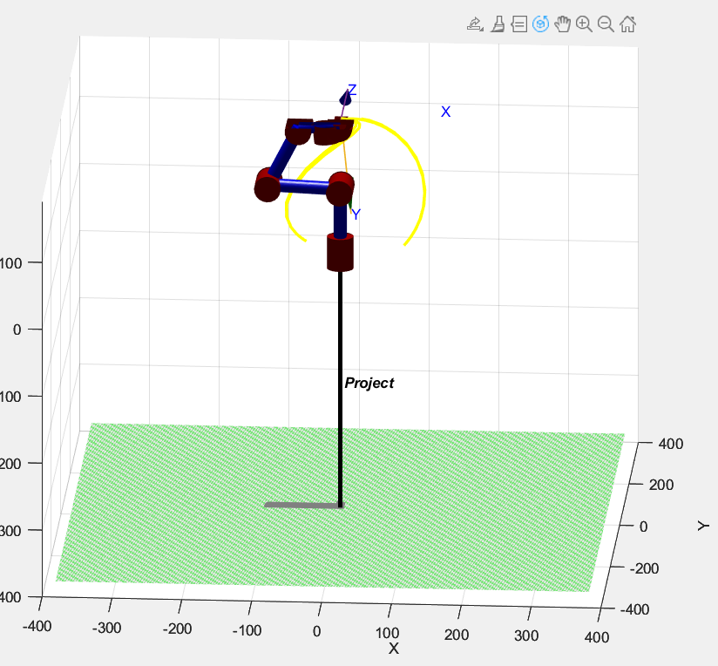

*Figure 15: Peter Corke Robotic Toolbox simulation of the standby position of 6DOF robotic arm.*

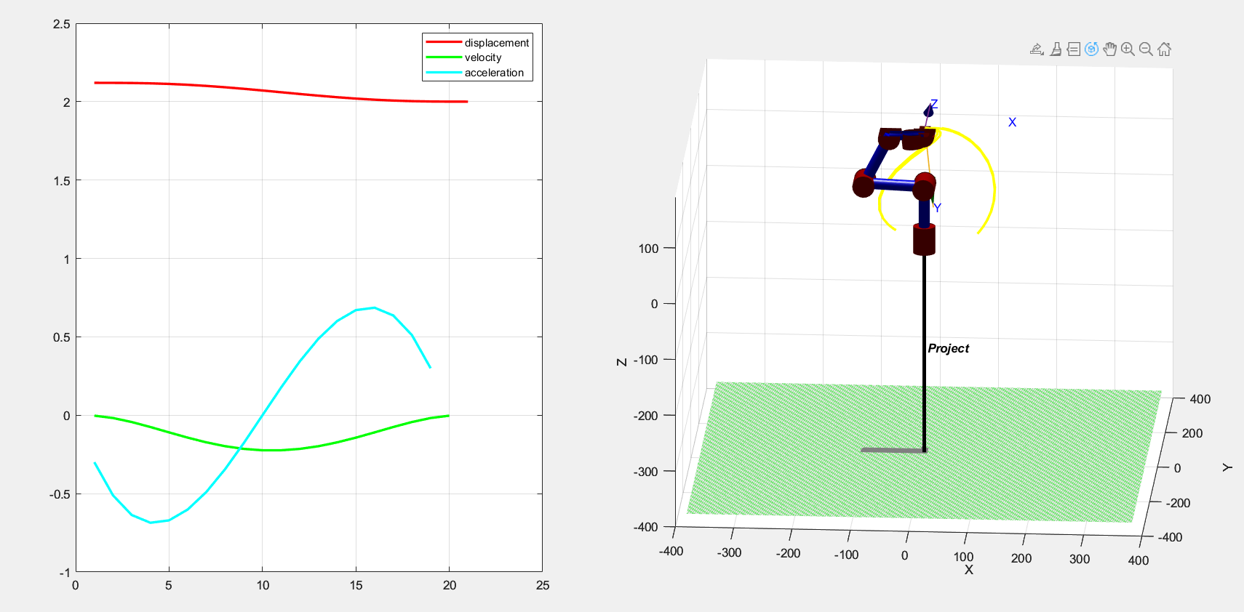

*Figure 16: Trajectory planning for the pre-defined path to determine the suitability of such motion.*

From the trajectory graph above, it is to ensure the acceleration and velocity of the motion is reasonable within the limit specification of the servo motor MG996R. It allows us to evaluate the system’s functionality and behavior as well as visualizing the robotic arm motion in workspace. The above simulation is controlled using Peter Corke Robotic Toolbox in MATLAB as provided in appendix.

**Joint Space Trajectory Planning Simulation**

The robotic arm has a degree of freedom (DOF) of 5. The robotic arm is in a cubit 3-3-3 configuration. Since the robotic arm is programmed to be highly customizable in terms of different via points, a specific trajectory pattern is selected to calculate in this report to show the trajectory planning in joint space. The tables below show one of the trajectory paths to pick up the planting samples process. Noted that 2 midpoints are added into trajectory planning to smoothen the path.

**Table 4: Joint angle in each corresponding via point.**

|  |  |  |  |  |  |  |
| --- | --- | --- | --- | --- | --- | --- |
| Joint | Initial  Point  (º) | Via  Point 1 (º) | Via  Point  2 (º) | Via  Point  3 (º) | Via  Point  4 (º) | Final  Point  5 (º) |
| 1 | 91 | 77 | 150 | 151 | 83 | 91 |
| 2 | 157 | 52 | 97 | 122 | 127 | 157 |
| 3 | 170 | 89 | 131 | 131 | 137 | 170 |
| 4 | 110 | 130 | 166 | 166 | 121 | 110 |
| 5 | 21 | 90 | 90 | 90 | 21 | 21 |

Initial point to midpoint 1 *t*1 = 1s 1s

Midpoint 1 to via point 1 *t*2 = 1s 2s

Via point 1 to 2 *t*3 = 2s 4s

Via point 2 to 3 *t*4 = 1s 5s

Via point 3 to 4 *t*5 = 2s 7s

Via point 4 to midpoint 2 *t*6 = 0.5s 7.5s

Midpoint 2 to final point *t*7 = 0.5s 8s

**Table 5: Trajectory Equations of Position Profile**

|  |  |  |
| --- | --- | --- |
| **Joint** | **Local**  **Time**  **(s)** | **Position Equations for each segment** |
| 1 | 0 ≤ t < 1  1 ≤ t < 2  2 ≤ t < 3  3 ≤ t < 5  5 ≤ t < 6  6 ≤ t < 7  7 ≤ t < 8 | $$θ_{1}=91-4.1873t^{3}$$ $$θ_{2}=86.8127-12.562\left(t+t^{2}\right)+15.3114t^{3}$$ $$θ_{3}=77+8.248t+33.37t^{2}-9.623t^{3}$$ $$θ_{4}=150+26.26t-24.37t^{2}-0.893t^{3}$$ $$θ_{5}=151-25.15t-27.04t^{2}+11.312t^{3}$$ $$θ_{6}=83+2.394t+40.818t^{2}-42.414t^{3}$$ $$θ_{7}=89.1+11.402t-22.803t^{2}+15.202t^{3}$$ |
| 2 | 0 ≤ t < 1  1 ≤ t < 2  2 ≤ t < 3  3 ≤ t < 5  5 ≤ t < 6  6 ≤ t < 7  7 ≤ t < 8 | $$θ_{1}=157-21.3794t^{3}$$ $$θ_{2}=135.62-64.14\left(t+t^{2}\right)+44.66t^{3}$$ $$θ_{3}=52-58.45t+69.83t^{2}-14.68t^{3}$$ $$θ_{4}=97+44.74t-18.24t^{2}-1.502t^{3}$$ $$θ_{5}=122+3.759t-22.74t^{2}+11.06t^{3}$$ $$θ_{6}=127+45.47t+43.6t^{2}-73.91t^{3}$$ $$θ_{7}=151.4+33.63t-67.27t^{2}+44.84t^{3}$$ |
| 3 | 0 ≤ t < 1  1 ≤ t < 2  2 ≤ t < 3  3 ≤ t < 5  5 ≤ t < 6  6 ≤ t < 7  7 ≤ t < 8 | $$θ_{1}=170-16.88t^{3}$$ $$θ_{2}=153.12-50.64\left(t+t^{2}\right)+37.17t^{3}$$ $$θ_{3}=89-40.42t+60.87t^{2}-15.08t^{3}$$ $$θ_{4}=131+22.11t-29.6t^{2}+7.496t^{3}$$ $$θ_{5}=131-14.61t-7.114t^{2}+7.96t^{3}$$ $$θ_{6}=137+52.45t+40.65t^{2}-75.61t^{3}$$ $$θ_{7}=163.94+36.39t-72.77t^{2}+48.52t^{3}$$ |
| 4 | 0 ≤ t < 1  1 ≤ t < 2  2 ≤ t < 3  3 ≤ t < 5  5 ≤ t < 6  6 ≤ t < 7  7 ≤ t < 8 | $$θ_{1}=110+3.2488t^{3}$$ $$θ_{2}=113.25+9.746\left(t+t^{2}\right)-2.741t^{3}$$ $$θ_{3}=130-21.01t+1.522t^{2}-1.514t^{3}$$ $$θ_{4}=166+8.925t-7.567t^{2}-1.358t^{3}$$ $$θ_{5}=166-10.28t-11.644t^{2}+2.766t^{3}$$ $$θ_{6}=121-23.65t+4.956t^{2}-10.81t^{3}$$ $$θ_{7}=111.8-10.59t+21.17t^{2}-14.12t^{3}$$ |
| 5 | 0 ≤ t < 1  1 ≤ t < 2  2 ≤ t < 3  3 ≤ t < 5  5 ≤ t < 6  6 ≤ t < 7  7 ≤ t < 8 | $$θ_{1}=21+13.77t^{3}$$ $$θ_{2}=34.77+41.3\left(t+t^{2}\right)-27.36t^{3}$$ $$θ_{3}=90+41.82t-40.78t^{2}+9.937t^{3}$$ $$θ_{4}=90-2.065t+18.84t^{2}-16.78t^{3}$$ $$θ_{5}=90-14.372t-31.49t^{2}+10.8t^{3}$$ $$θ_{6}=21-11.10t+33.3t^{2}-25.9t^{3}$$ $$θ_{7}=20.54+2.775t-5.549t^{2}+3.7t^{3}$$ |

**Table 6: Trajectory Equations of Velocity Profile**

|  |  |  |
| --- | --- | --- |
| **Joint** | **Local**  **Time**  **(s)** | **Position Equations for each segment** |
| 1 | 0 ≤ t < 1  1 ≤ t < 2  2 ≤ t < 3  3 ≤ t < 5  5 ≤ t < 6  6 ≤ t < 7  7 ≤ t < 8 | $$θ_{1}=-12.562t^{2}$$ $$θ_{2}=-12.562-25.124t+45.93t^{2}$$ $$θ_{3}=8.2481+66.74t-28.8694t^{2}$$ $$θ_{4}=26.259-48.73t-2.6783t^{2}$$ $$θ_{5}=-25.15-54.0898t+33.9314t^{2}$$ $$θ_{6}=2.394+81.6359t-127.242t^{2}$$ $$θ_{7}=11.4015-45.606t+45.606t^{2}$$ |
| 2 | 0 ≤ t < 1  1 ≤ t < 2  2 ≤ t < 3  3 ≤ t < 5  5 ≤ t < 6  6 ≤ t < 7  7 ≤ t < 8 | $$θ_{1}=-64.1381t^{2}$$ $$θ_{2}=-64.1381-128.276t+133.97t^{2}$$ $$θ_{3}=-58.4476+139.6571t-44.0321t^{2}$$ $$θ_{4}=44.7382-36.4713t-4.50748t^{2}$$ $$θ_{5}=3.7594-45.4863t+33.1702t^{2}$$ $$θ_{6}=45.4676+87.19451t-221.727t^{2}$$ $$θ_{7}=33.6331-134.532t+134.532t^{2}$$ |
| 3 | 0 ≤ t < 1  1 ≤ t < 2  2 ≤ t < 3  3 ≤ t < 5  5 ≤ t < 6  6 ≤ t < 7  7 ≤ t < 8 | $$θ_{1}=-50.6446t^{2}$$ $$θ_{2}=-50.6446-101.289t+11.5125t^{2}$$ $$θ_{3}=-40.4214+121.7357t-45.2357t^{2}$$ $$θ_{4}=22.1072-59.207t-22.48878t^{2}$$ $$θ_{5}=-14.6110-14.2294t+23.8803t^{2}$$ $$θ_{6}=52.4514+81.2918t-226.84t^{2}$$ $$θ_{7}=36.3872-145.549t+145.5486t^{2}$$ |
| 4 | 0 ≤ t < 1  1 ≤ t < 2  2 ≤ t < 3  3 ≤ t < 5  5 ≤ t < 6  6 ≤ t < 7  7 ≤ t < 8 | $$θ_{1}=9.7463t^{2}$$ $$θ_{2}=9.7463+19.4925t-8.2238t^{2}$$ $$θ_{3}=21.015+3.0449t-4.5449t^{2}$$ $$θ_{4}=8.9252-15.1347t-4.0736t^{2}$$ $$θ_{5}=-10.283-23.2818t+8.2986t^{2}$$ $$θ_{6}=-23.6521+9.913t+32.435t^{2}$$ $$θ_{7}=-10.587+42.348t-42.3479t^{2}$$ |
| 5 | 0 ≤ t < 1  1 ≤ t < 2  2 ≤ t < 3  3 ≤ t < 5  5 ≤ t < 6  6 ≤ t < 7  7 ≤ t < 8 | $$θ_{1}=41.297t^{2}$$ $$θ_{2}=41.297+82.5935t-82.0773t^{2}$$ $$θ_{3}=41.813-81.5611t+29.8111t^{2}$$ $$θ_{4}=-2.0648+37.6833t-50.3304t^{2}$$ $$θ_{5}=-14.712-62.9776t+32.39214t^{2}$$ $$θ_{6}=-11.0985+66.591t-77.6895t^{2}$$ $$θ_{7}=-2.7746-11.0985t+11.0985t^{2}$$ |

**Table 7: Trajectory Equations of Acceleration Profile**

|  |  |  |
| --- | --- | --- |
| **Joint** | **Local**  **Time**  **(s)** | **Position Equations for each segment** |
| 1 | 0 ≤ t < 1  1 ≤ t < 2  2 ≤ t < 3  3 ≤ t < 5  5 ≤ t < 6  6 ≤ t < 7  7 ≤ t < 8 | $$θ_{1}=-25.1241t$$ $$θ_{2}=-25.1241+91.86845t$$ $$θ_{3}=66.74439-57.7388t$$ $$θ_{4}=-48.7332-5.35661t$$ $$θ_{5}=-54.0898+67.86284t$$ $$θ_{6}=81.63591-254.484t$$ $$θ_{7}=-45.606+91.21197t$$ |
| 2 | 0 ≤ t < 1  1 ≤ t < 2  2 ≤ t < 3  3 ≤ t < 5  5 ≤ t < 6  6 ≤ t < 7  7 ≤ t < 8 | $$θ_{1}=-128.276t$$ $$θ_{2}=-128.276+267.9333t$$ $$θ_{3}=139.6571-88.0642t$$ $$θ_{4}=-36.4713-9.01496t$$ $$θ_{5}=-45.4863+66.3404t$$ $$θ_{6}=87.19451-443.454t$$ $$θ_{7}=-134.532+269.0648t$$ |
| 3 | 0 ≤ t < 1  1 ≤ t < 2  2 ≤ t < 3  3 ≤ t < 5  5 ≤ t < 6  6 ≤ t < 7  7 ≤ t < 8 | $$θ_{1}=-101.289t$$ $$θ_{2}=-101.289+223.0249t$$ $$θ_{3}=121.7357-90.4713t$$ $$θ_{4}=-59.207-44.97756t$$ $$θ_{5}=-14.2294+47.7606t$$ $$θ_{6}=81.29177-453.681t$$ $$θ_{7}=-145.549+291.0973t$$ |
| 4 | 0 ≤ t < 1  1 ≤ t < 2  2 ≤ t < 3  3 ≤ t < 5  5 ≤ t < 6  6 ≤ t < 7  7 ≤ t < 8 | $$θ_{1}=19.49252t$$ $$θ_{2}=19.49252-16.4476t$$ $$θ_{3}=3.044888-9.08978t$$ $$θ_{4}=-15.1347-8.14713t$$ $$θ_{5}=-23.2818+16.59726t$$ $$θ_{6}=9.912718-64.87032t$$ $$θ_{7}=42.34788-84.6958t$$ |
| 5 | 0 ≤ t < 1  1 ≤ t < 2  2 ≤ t < 3  3 ≤ t < 5  5 ≤ t < 6  6 ≤ t < 7  7 ≤ t < 8 | $$θ_{1}=82.59352t$$ $$θ_{2}=82.59352-164.155t$$ $$θ_{3}=-81.5611-59.62219t$$ $$θ_{4}=37.68329-100.661t$$ $$θ_{5}=-62.9776+64.78429t$$ $$θ_{6}=66.59102-115.379t$$ $$θ_{7}=-11.0985+22.19701t$$ |

**Joint 1 Profile:**

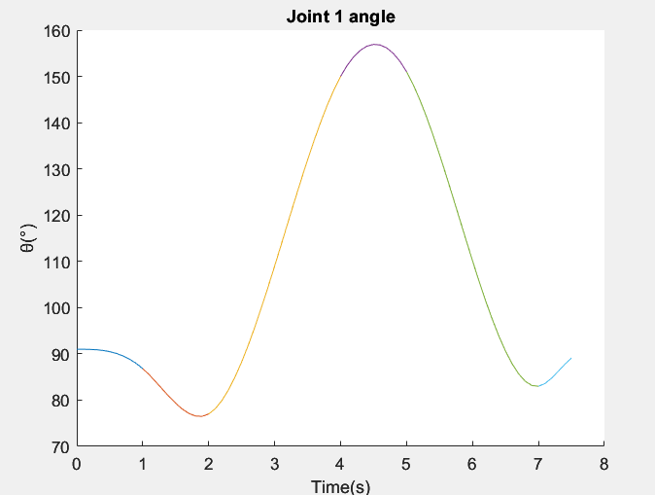

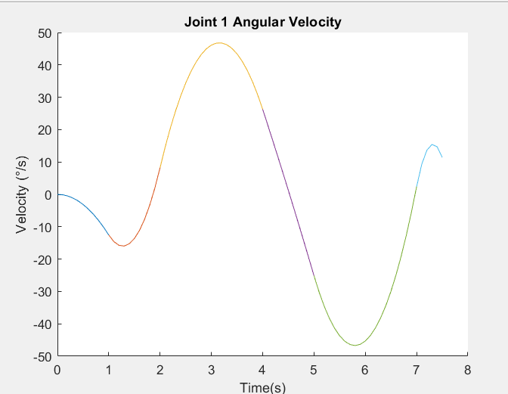

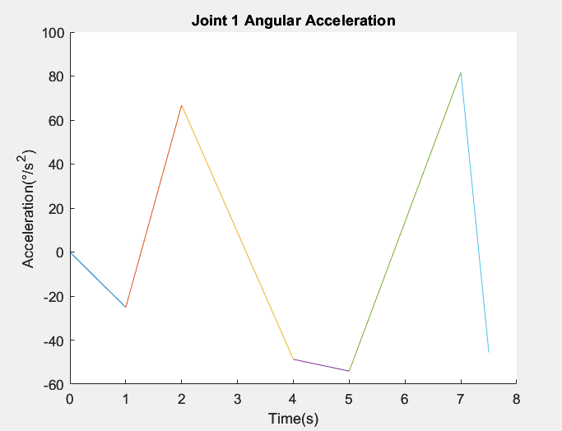

**Joint 2 Profile:**

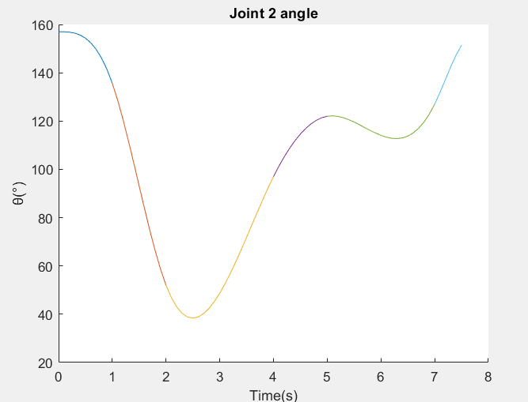

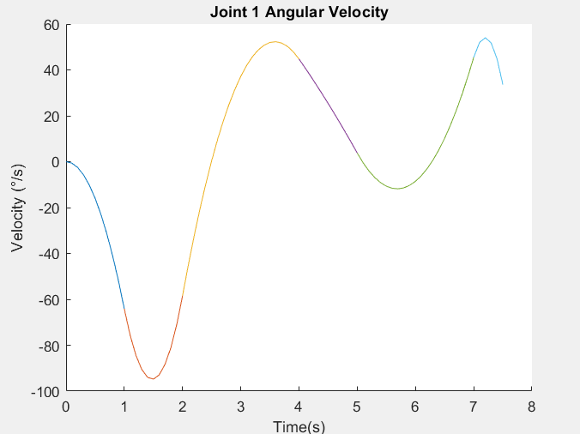

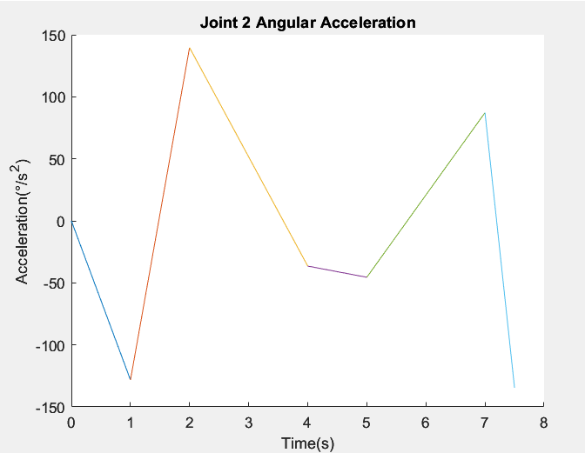

**Joint 3 Profile:**

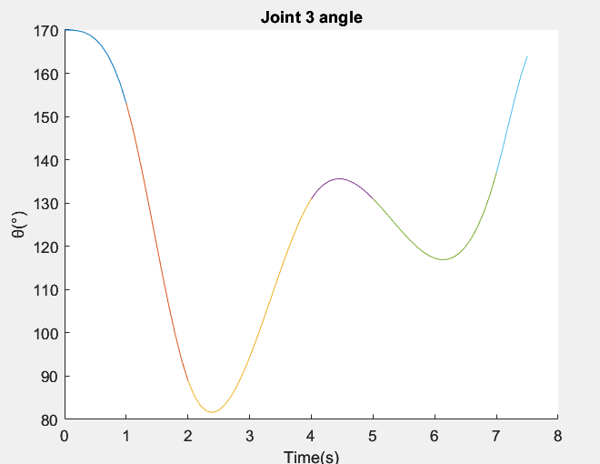

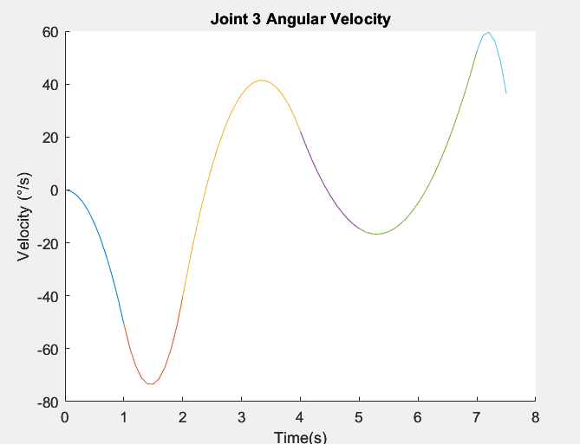

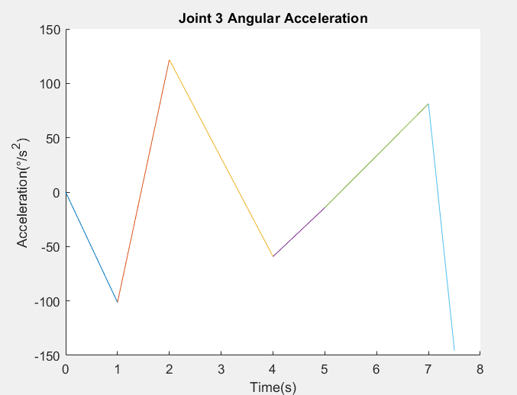

**Joint 4 Profile:**

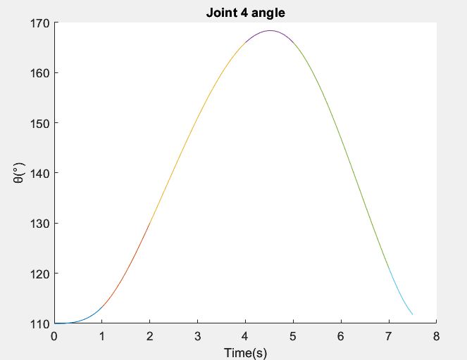

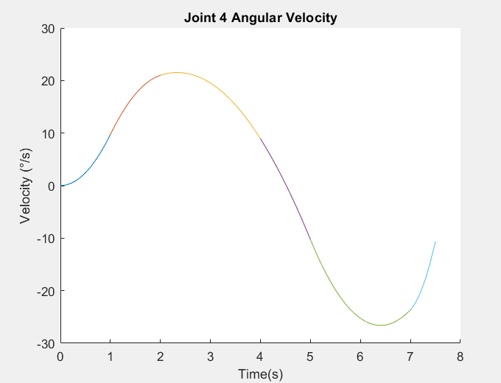

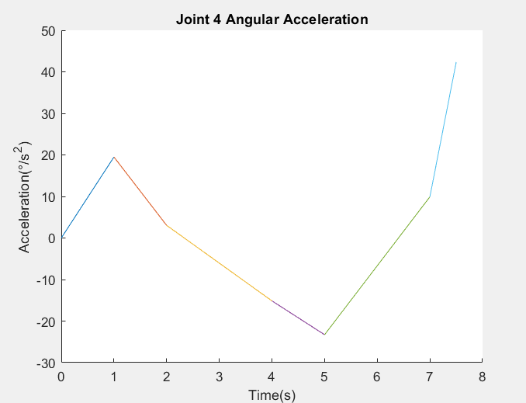

**Joint 5 Profile:**

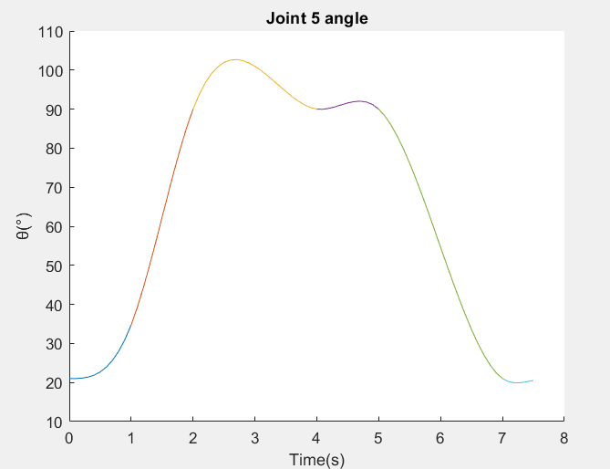

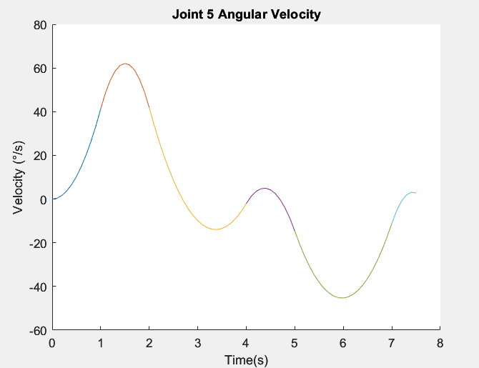

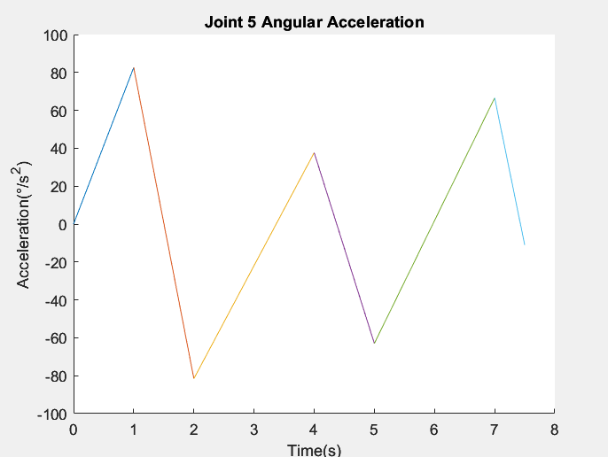

5. discussion

**Weaknesses**

The proposed robotic arm got some weaknesses that can be improved to have better performance. It faces challenges such as calibration accuracy and adaptability to different agricultural environments which affecting the overall performance.

On the other hand, the motion of proposed robotic arm is not flexible enough due to programming algorithm and project development time constraint. The programming algorithm does not account for real-time adaptability, it may not respond effectively to dynamic changes or unforeseen obstacles in the environment.

The supported frame is not 100% sturdy when performing fast picking up action. The design of the supported frame might not be robust or rigid enough to handle the dynamic forces involved in fast picking up actions. The frame should be appropriately designed, considering factors such as material selection, cross-sectional dimensions, and reinforcement elements to ensure sufficient stiffness and strength.

In term of electronic and software, the LabVIEW equipped toolbox is convenient enough to implement complex functions such as trajectory planning and camera vision. However, it is not suitable for doing very complex tasks such as image processing and complex robotic algorithm implementation. The implementation of simple algorithm along with camera vision is very slow during the development and testing, Besides, the trajectory toolbox provided is not flexible as no parameters could be altered to smoothen the robotic arm motion. The overall motion is very rigid compared to industrial robotic arm.

**Future works**

For the robotic arm to adapt in different agricultural environments, wheels can be mounted on the base of the robotic arm to increase its mobility. Wheels allow the robotic arm to move and navigate within its environment. By providing the ability to drive or roll, the arm can easily reposition itself or traverse different areas without the need for external assistance. This mobility enhances the arm's flexibility and versatility in performing tasks in various agricultural environments.

The supported frame should be structural reinforcement. Weak points or areas of the frame that are prone to flexing or deformation under load are identified and reinforce those areas by adding additional structural elements such as gussets, braces, or cross-members. These reinforcements can help distribute the applied forces more evenly and enhance the overall rigidity of the frame.

The flexible of motion of a proposed robotic arm can be improved by incorporating real-time sensing and feedback mechanisms in the algorithm, such as vision systems or force/torque sensors, can enable the arm to adapt and adjust its motions flexibly.

For improvement, depth sensor camera can be added as it could provide 3D coordinates. Depth sensors allow robots to create detailed 3D maps of their surroundings, facilitating tasks such as autonomous exploration, scene reconstruction, and augmented reality. Complete Jacobian and Inverse kinematics algorithm combined with Depth sense camera could derive the angle variables directly from camera input.

Multiple electronic controllers could be implemented with serial communication method to provide better development environment and enhance the capabilities of the 6DOF robotic arm. Besides, adding extra peripherals such as LED screen, touchscreen and other interactive elements to provide better user experience.

**Environment and Sustainability**

Impact of development of 7-axis robotic arm in agricultural phenotyping towards Sustainability Development Goal

**SDG 2: Zero Hunger**

The use of a 7-axis robotic arm in agricultural phenotyping can improve crop productivity and efficiency. It can automate tasks such as plant measurement, data collection, and analysis, leading to better understanding of crop characteristics and growth patterns. This information can help optimize agricultural practices, enhance crop yields, and contribute to achieving food security.

**SDG 9: Industry, Innovation, and Infrastructure**

The development of advanced robotic arms demonstrates innovation in agricultural technology. By integrating sophisticated automation and precision into the agricultural sector, it can improve the efficiency and sustainability of farming practices. This can contribute to the development of resilient infrastructure and promote sustainable industrialization.

**SDG 12: Responsible Consumption and Production**

The use of a 7-axis robotic arm in agricultural phenotyping can promote sustainable production practices. By enabling precise measurements and data-driven decision-making, it reduces waste, optimizes resource utilization, and minimizes the use of chemicals and inputs. This supports responsible consumption and production patterns and fosters more sustainable agricultural systems.

6. CONCLUSION

There are few weaknesses of the robotic arm into proper agricultural phenotyping due to the constraint of development time and several factors. However, the overall robotic arm is ready to use and could be upgraded with various functions such as inverse kinematic algorithm implementation and image processing are possible in the future. Besides, the trajectory planning could be integrated with different action times depending on the distance between each via point.

The development of this project is aimed to achieve the SDG2, 9, and 12 where the advancement of robotic technology in agriculture could reduce the urgency of food shortages along with the booming human population in the new tens’ years. The phenotyping technology could easily examine the crop performance genetic variations and more characteristics without much labor cost. Besides, its highly reusability promotes sustainability in robotic industries especially crucial in 3rd world countries.

The 6DOF robotic arm developed is relatively successful with more room for improvement. The kinematic analysis, Jacobian matrix, inverse kinematic and dynamic analysis were performed for the robotic arm. The 6DOF robotic arm could move smoothly with the help of the built-in robotic toolbox integrated in the LabVIEW. Besides, the additional functionality such as manual calibration and motion sequence tester, as well as the camera live view are integrated in this project within a short development time. Generally, the objectives of the project are achieved successfully. In the future, this article hopefully provides insight and guidelines into the whole development and integration of 6DOF robotic arm into various field without going through the same development process.

6. Reference

1. Munir, S. (2023, June 12). *University of Texas at Arlington Employs Husky UGV for Automated Plant Phenotyping - Clearpath Robotics*. Clearpath Robotics. <https://clearpathrobotics.com/blog/2023/06/university-of-texas-at-arlington-employs-husky-ugv-for-automated-plant-phenotyping/>
2. *Sustainable Development Goals | United Nations Development Programme*. (2015). UNDP.

<https://www.undp.org/sustainable-development-goals>

1. pruce. (2023, February 16). *What is 6 degrees of freedom robotic arm？*. Huiling Tech. <https://www.hitbotrobot.com/freedom-robotic-arm/>
2. *VisibleBreadcrumbs*. (2023). Mathworks.com. <https://www.mathworks.com/help/sm/ug/urdf-model-import.html>
3. WLKATA Robotics. (2023). *WLKATA Robotics Documents Center | WLKATA Robotics Document | WLKATA Robotics Document*. WLKATA Robotics. <https://document.wlkata.com/?doc=/wlkata-mirobot-resources-for-education/matlab-and-coppeliasimv-rep/>
4. Alam, M. M., Siwar, C., Murad, M. W., & Toriman, M. (2017, March 27). *Impacts of Climate Change on Agriculture and Food Security Issues in Malaysia: An Empirical Study on Farm Level Assessment*. Ssrn.com. <https://papers.ssrn.com/sol3/papers.cfm?abstract_id=2941495>
5. ‌*Robotics Toolbox - Peter Corke*. (2020, April 27). Peter Corke.   
   <https://petercorke.com/toolboxes/robotics-toolbox/>

8. APPENDIX

|  |  |  |  |  |  |  |  |  |  |  |  |
| --- | --- | --- | --- | --- | --- | --- | --- | --- | --- | --- | --- |
| Month | April | May | | | | June | | | | | July |
| Milestone | W4 | W1 | W2 | W3 | W4 | W1 | W2 | W3 | W4 | W1 | |
| Milestone  1 |  |  |  |  |  |  |  |  |  |  | |
| Milestone  2 |  |  |  |  |  |  |  |  |  |  | |
| Milestone  3 |  |  |  |  |  |  |  |  |  |  | |
| Milestone  4 |  |  |  |  |  |  |  |  |  |  | |
| Milestone  5 |  |  |  |  |  |  |  |  |  |  | |

Table 8: Project Management Gantt Chart

Milestone 1: Research on robot that has similar functions (Risk Mitigation), Research on the working principle and characteristics of 6DOF robotic arm in agriculture. Research on MyRIO controller and its programming language.

Milestone 2: CAD design of the robotic arm using SolidWorks and simulation of the designed robotic arm with URDF file functionality testing in V-REP platform (Risk Mitigation).

Milestone 3: Forward kinematic, inverse kinematic, dynamic analysis and Jacobian derivation using MATLAB. LabVIEW programming prototype is prepared.

Milestone 4: Preparation of LabVIEW programming along with 6DOF robotic arm implementation and testing. Design joint space controller for robotic arm in V-REP platform controlled with MATLAB (Risk Mitigation), trajectory path planning for the end effector movement, program flowchart construction.

Milestone 5: Implementation of the 6DOF robotic arm in real life situation. Testing the simulation program of the robotic arm. report writing and video presentation preparation.

**Contribution of Group Members**

|  |  |
| --- | --- |
| **Name** | **Contribution** |
| Lai Hong You | * Methodology * Discussion * Calculation of Inverse Kinematics * Trajectory Planning Analysis * SOLIDWORKS * Simulation * Power circuitry implementation of robotic arm |
| Justin Chia Vern Shuen | * Introduction * Methodology * Conclusion * Dynamic Equation Analysis * Trajectory Planning Analysis and simulation * LabVIEW Programming |
| Thow Zhi An | * Methodology * Discussion * CAD Design and Laser Cutting * Calculation of Inverse Kinematics * Calculation of Jacobian * SOLIDWORKS * Power circuitry design of robotic arm |
| Tiong Ji Kai | * Methodology * Calculation of Forward Kinematics * Calculation of Jacobian * Calculation of Inverse Kinematics * Dynamic Equation Analysis * SOLIDWORKS |